DevOps Document

Contents

V1 4

Setup 4

GitLab 4

Jenkins 6

Kubernetes 7

SonarQube 9

Snyk 14

OWASP ZAP 14

CI/CD 15

Overview Diagram 15

CI 16

CD 16

V2 17

Introduction 17

Kubernetes Files 18

Configuration files 18

Service Files 23

Docker files 35

Backend Service Docker files 35

Frontend Docker files 40

Jenkins 43

Jobs 43

Setup 63

Jenkins Server 63

SonarQube VM 73

Snyk VM 77

Testing 79

Environments 79

Tests 81

Monitoring 100

Logs 100

Metrics 102

Traces 104

Profiling 106

Security dashboards 109

Conclusion 109

# V1

# Setup

For my individual project I have 2 pipeline setups, the reason for that is that I first started using Jenkins on netlab server and started to have problems with connections to the repository, so I had to switch to gitlab built it CI/CD using runners. For sake of time saving, I will be using the gitlab pipeline but if I can at a certain point I will switch to Jenkins.

## GitLab

For gitlab I have a simple runner with the following config:

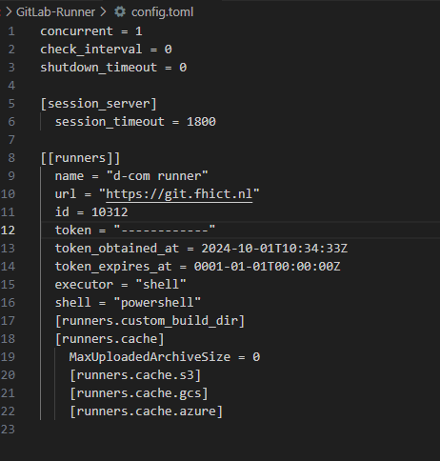

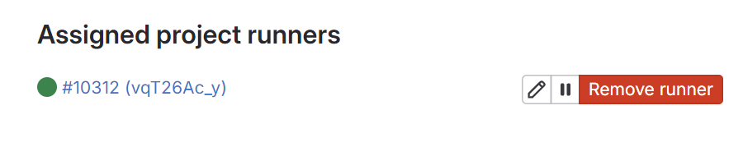

To complement it I have the gitlab pipeline file:

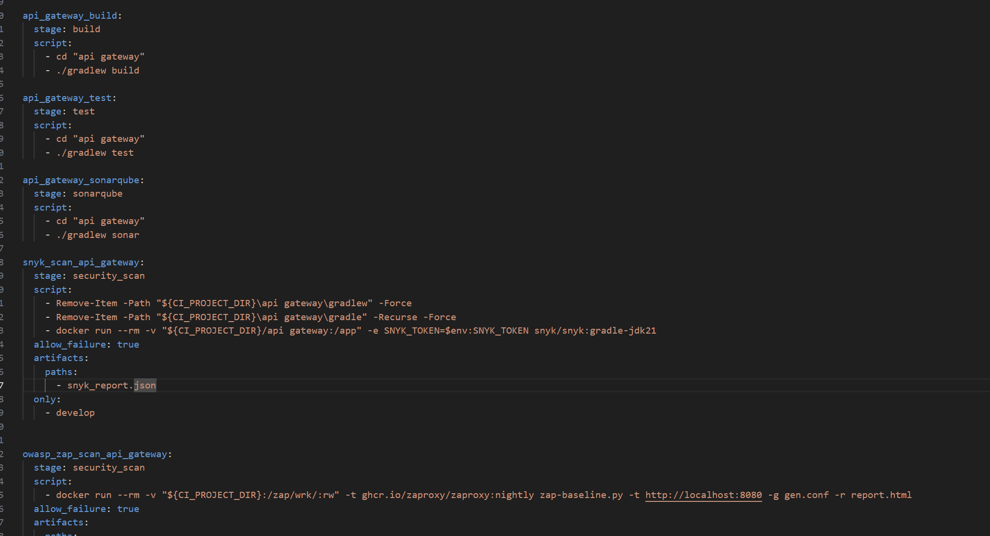

This the pipeline file for the current pipeline. In here is displayed a portion of the services but the structure is the same for all of them.

## Jenkins

For the Jenkins currently I have a ubuntu server in the netlab running a Jenkins container in docker.

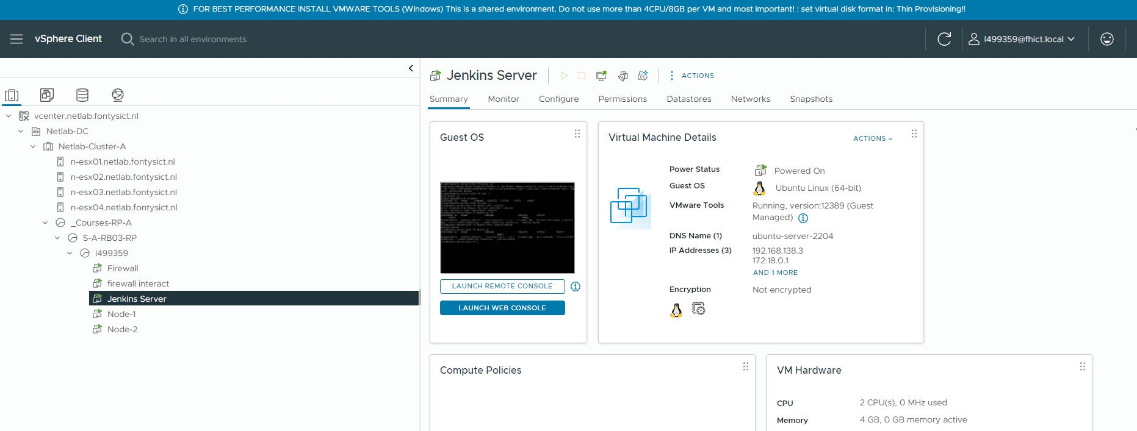

I also installed the gitlab plugin to help the connection and interaction with gitlb repositories.

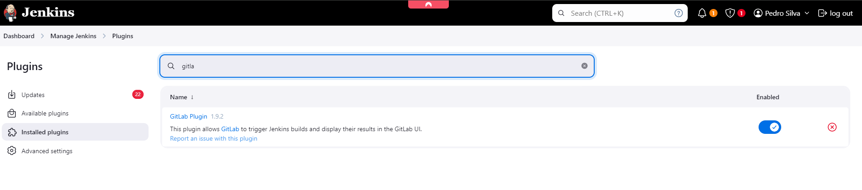

After that I created a job, but this is where I had the problems with connecting to the repository, because even though I can connect to the gitlab server I cannot connect to the actual repository and to save time I just left it here and will pick it up at a later stage.

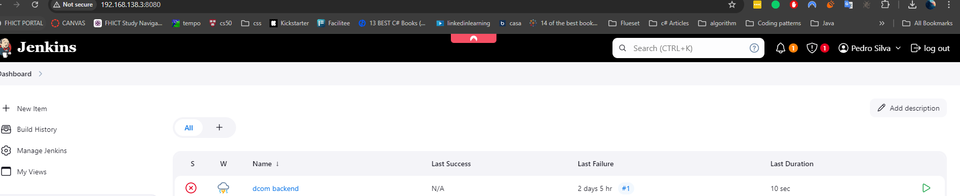

## Kubernetes

Currently I also have a small testing Kubernetes cluster hosted in the netlab for concept testing, however I plan to offload this to the cloud.

Master node:

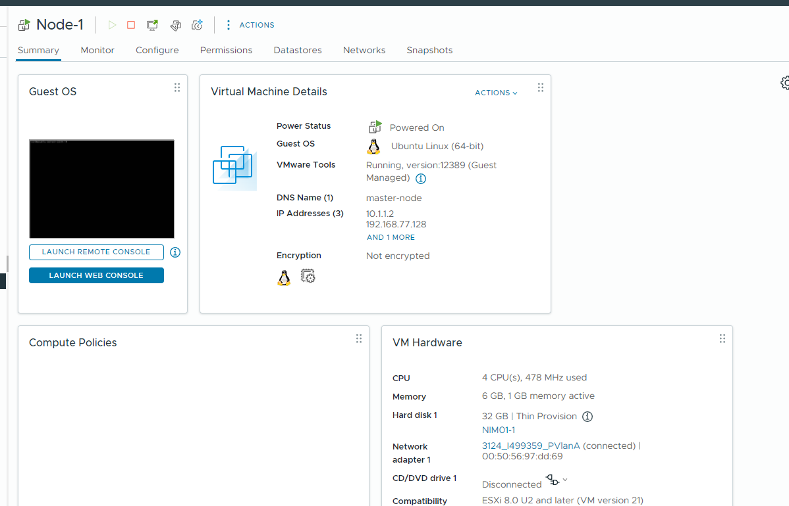

Worker node 1

s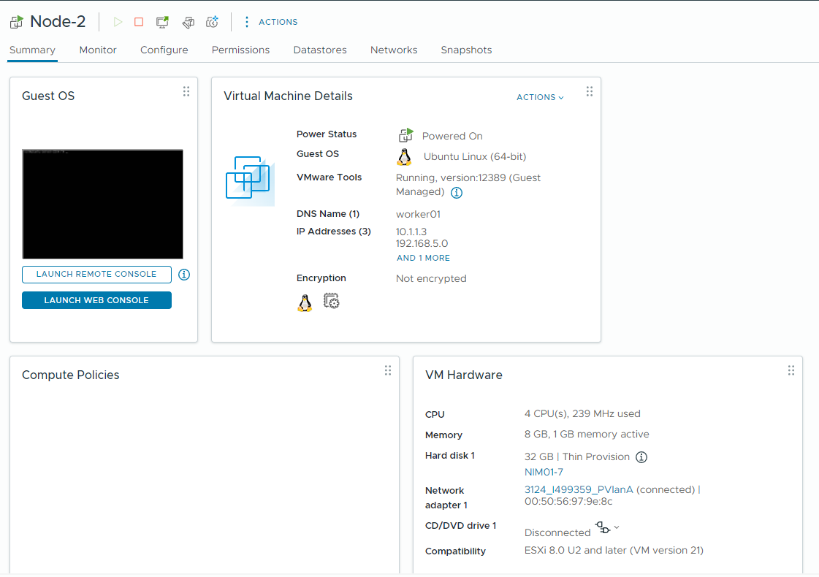

List of nodes of the cluster:

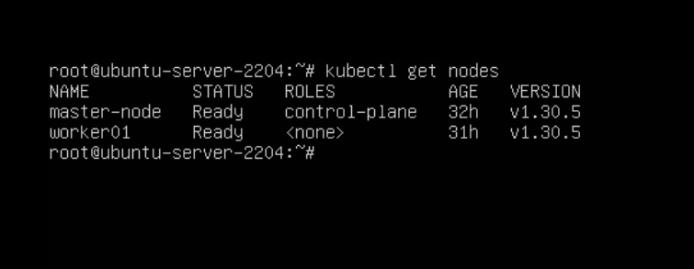

I also have an internal load balancer using metalb, however this is still in a very early implementation phase.

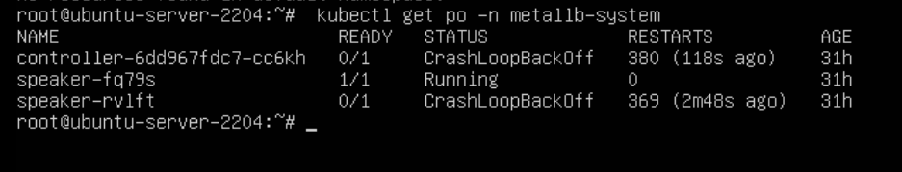

## SonarQube

To have a local SonarQube server is a very straightforward process.

First, we need to install it via docker just to make it easier.



Once we login we can create a new project.

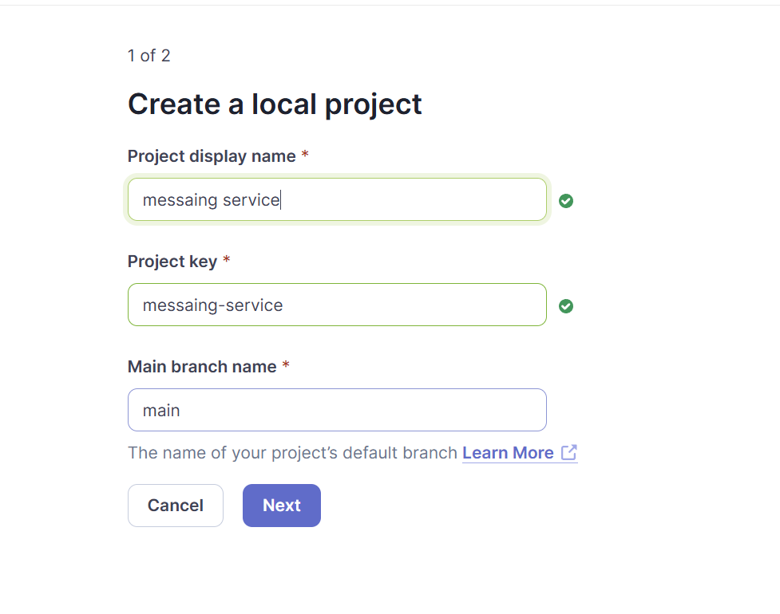

We select the following options

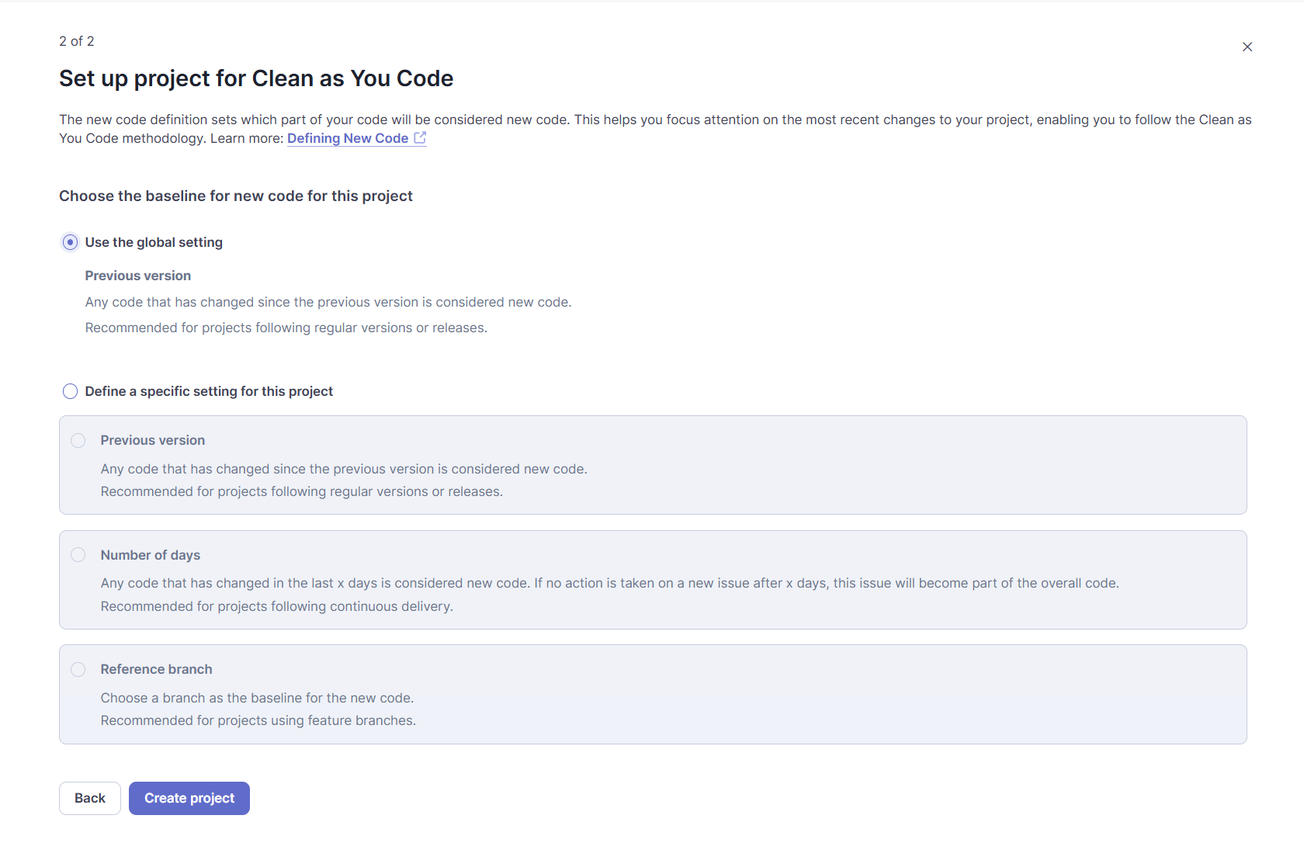

In here since I’m running it locally I’m selecting locally.

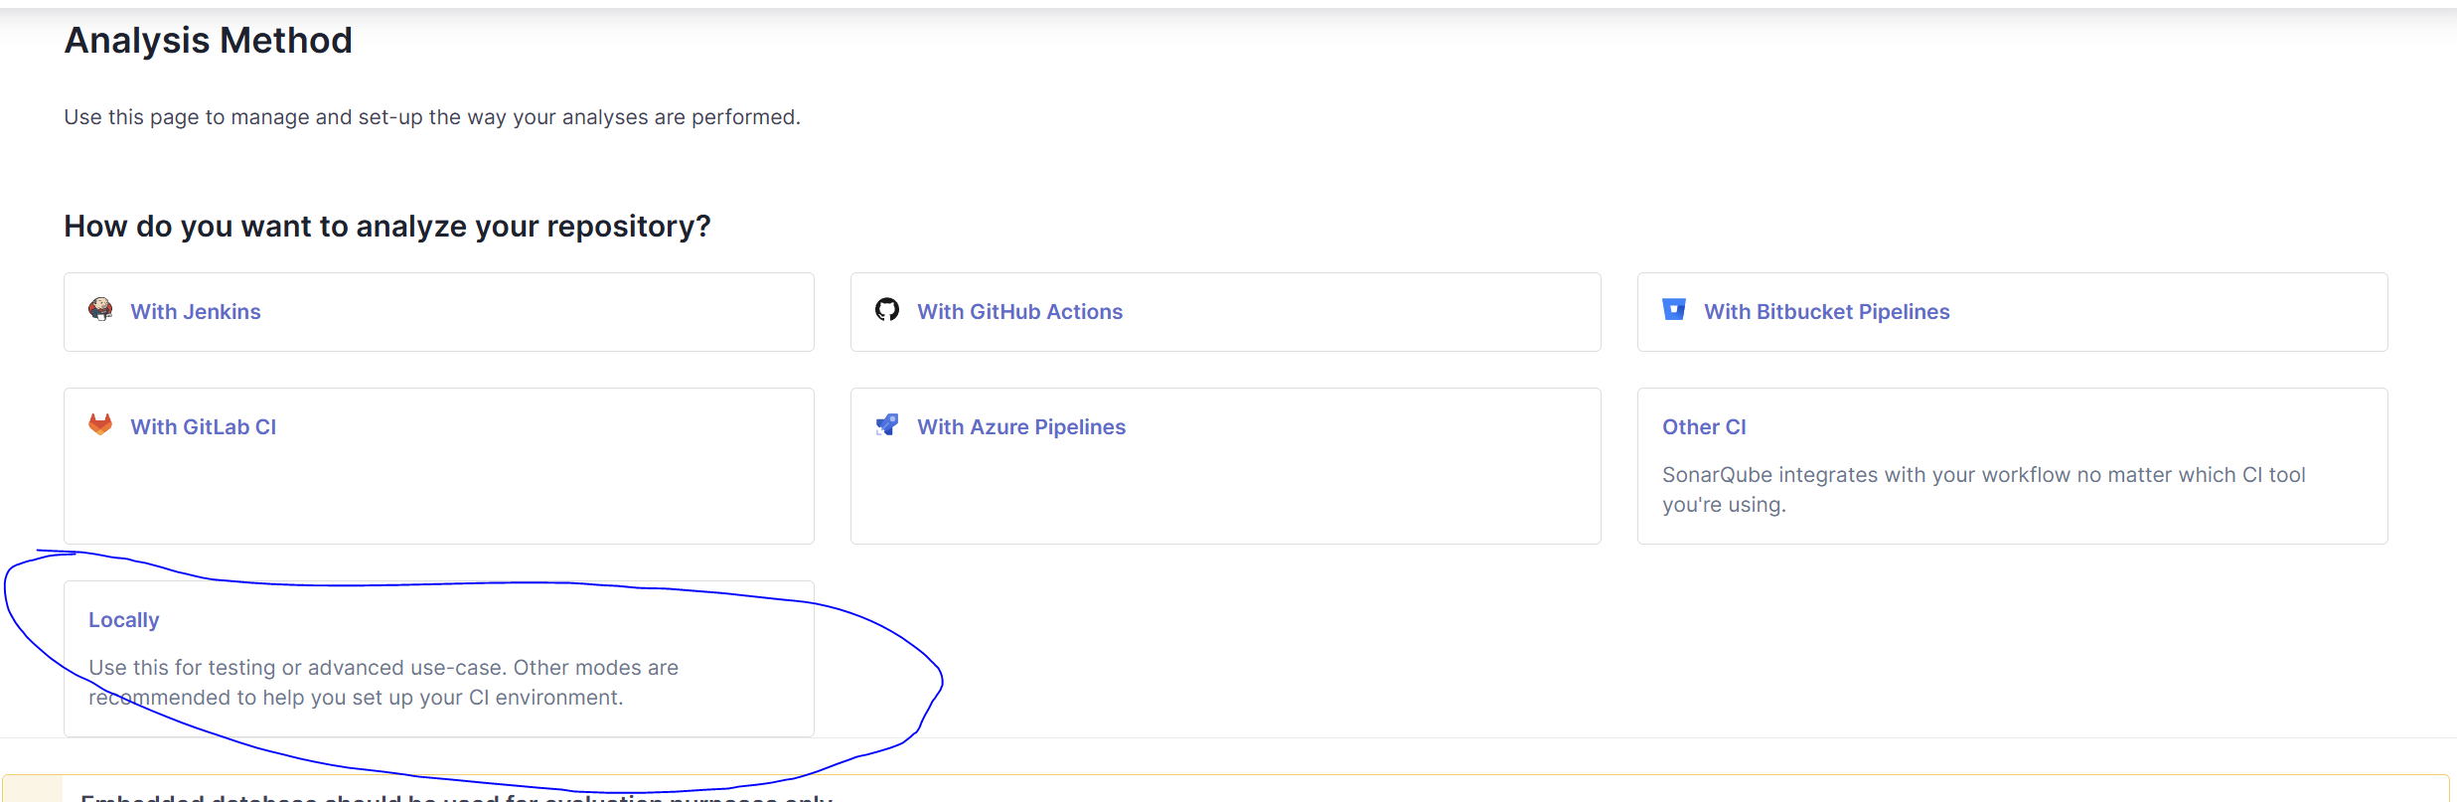

Once we select our token time, we get these instructions to apply to the application.

(Since this is local, I don’t mind having the token documented)

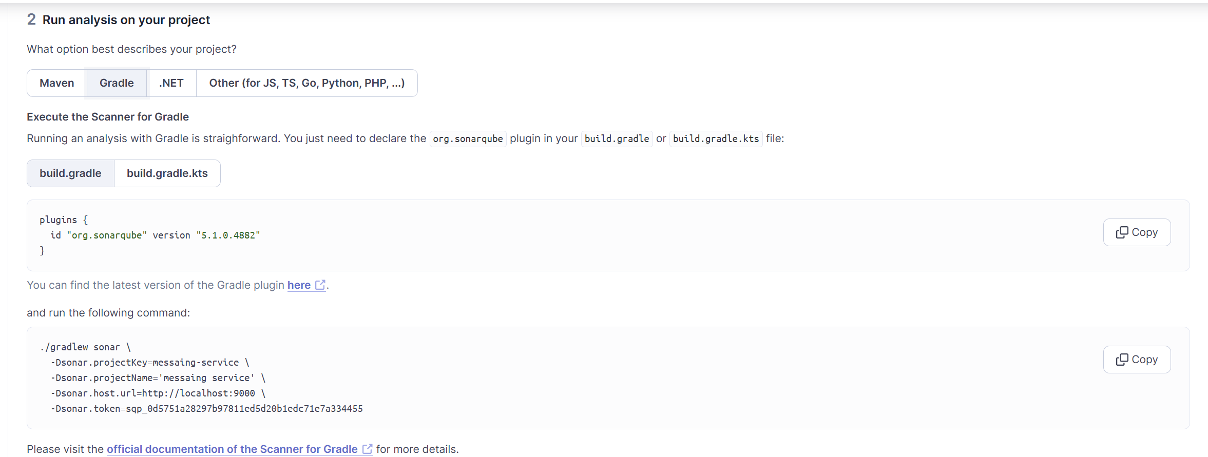

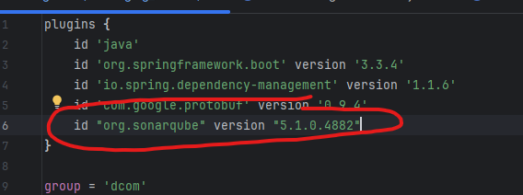

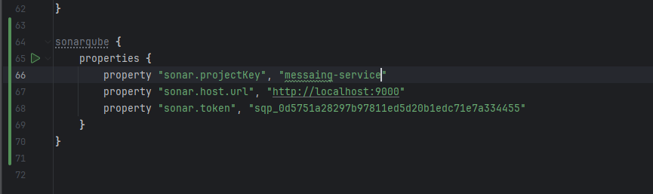

Now we build the project and after run the “sonar” command.

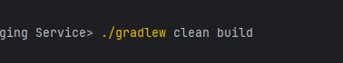

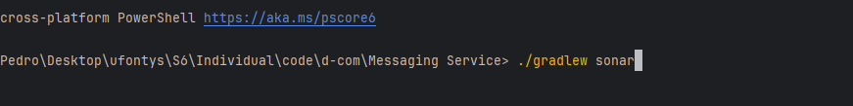

After that if we go to our SonarQube project we will see the analysis there and we have added SonarQube successfully.

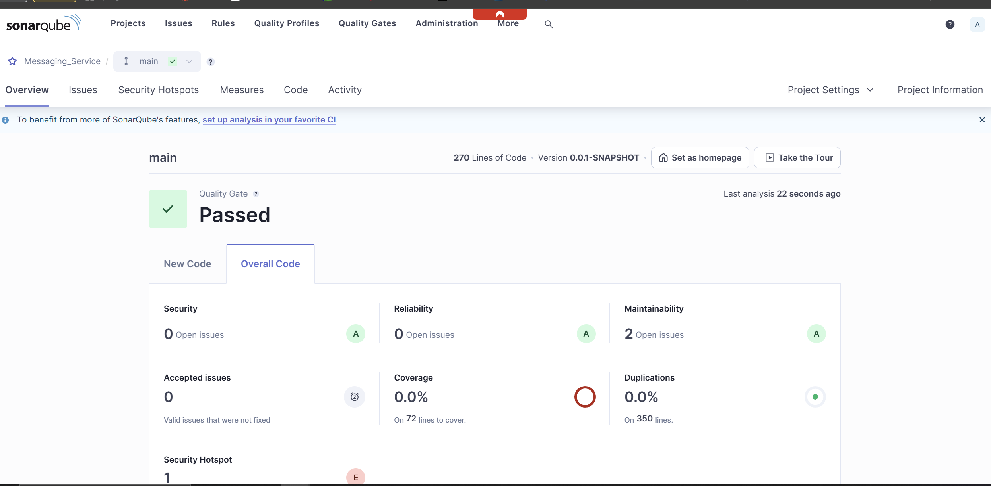

## Snyk

To add Snyk is a very easy job. For snyk we can spawn a onetime container that is mounted to our application’s directory so that it can scan it inside the container and return the report.



“docker run --rm -v "${CI_PROJECT_DIR}/api gateway:/app" -e SNYK_TOKEN=$env:SNYK_TOKEN snyk/snyk:gradle-jdk21”

## OWASP ZAP

Like synk, owasp zap also runs inside a docker container and doesn’t need to be setup anywhere else. The only thing to keep in mind here is that we need to pass the correct url to be tested.



“docker run --rm -v "${CI_PROJECT_DIR}:/zap/wrk/:rw" -t ghcr.io/zaproxy/zaproxy:nightly zap-baseline.py -t $SERVICE_URL -g gen.conf -r report.html”

# CI/CD

## Overview Diagram

This the overall diagram of the pipeline for any of the services of the application.



## CI

For this project the continuous integration portion is made of 3 stages, these stages apply to all services:

* Build:

In this stage I just build the service to get the required binary

* Test:

In this stage I perform all testing for the service in question

* Code Analysis:

In this stage I run a SonarQube analysis on the service code to ensure the quality

* Security Scan:

In this stage I run Snyk and OWASP ZAP for vulnerable libraries and dynamic application analysis respectively.

## CD

For the project the continuous delivery is made of 2 stages, like the CI they apply to all services:

* Dockerize:

In this stage I build image for the service, and we upload it to the repository.

* Deploy:

In this stage I trigger the commands on the Kubernetes cluster to pull the new images and create the new pods.

# V2

This is the current and final version of the DevOps process. V1 was my initial draft and implementation but after that everything gradually changed to the current state.

## Introduction

The current DevOps process has a couple of components that I will explain in detail, but for now I’m just mentioning them has a quick overview.

* Jenkins with worker nodes

Jenkins server with worker nodes for specific tasks.

* Snyk VM

Snyk VM responsible for running the Snyk analysis jobs.

* SonarQube VM

SonarQube VM responsible for running the SonarQube scans for all the services.

* Test Environment VM

This VM is responsible for being the environment where the system tests run.

* Terraform

Terraform is crucial for scripting the creation of the cloud resources

* GitLab

Version Controller system used to store the code.

* Google Cloud

Main cloud platform where the services and their components reside.

Before going into the description of the Jenkins jobs I will first explain some of the files that will be used throughout the pipeline, these being Kubernetes files and docker files. There is also an explanation about the terraform files I use but that can be found in the “Terraform” word document.

## Kubernetes Files

For the files I will separate them into two categories: Setup files and service files. The difference being that setup files are files that I use to configure an aspect of Kubernetes like credentials, while service files are files specific for each service deployment so files like pod deployment, service, hpa.

### Configuration files

#### app-secrets.yaml

For this file to make sense there is a need for a bit of context. Google cloud Kubernetes solution offers a way to import secrets from their secret manager into a pod, for this to happen there needs to be a particular configuration done in Kubernetes to tell google which services I want to make available to the cluster to mount to the pod. This file defines the secrets that will be imported.

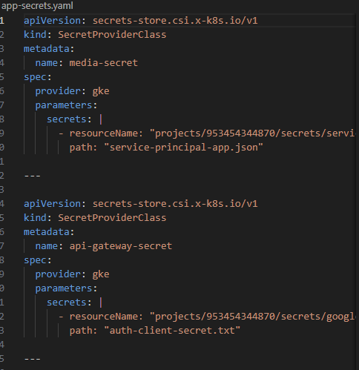

*File content example*

#### Ingress templates

Before going into the ingress files, I want to point out that currently I make use of helm to manage different Kubernetes environments and the ingress controller is the first case where I use helm, this implies that there are template files and those are the ones I’m going through.

The first one is the template for the ingress configuration itself. In here I set just a very basic baseline that is later filled in by helm using the value files.

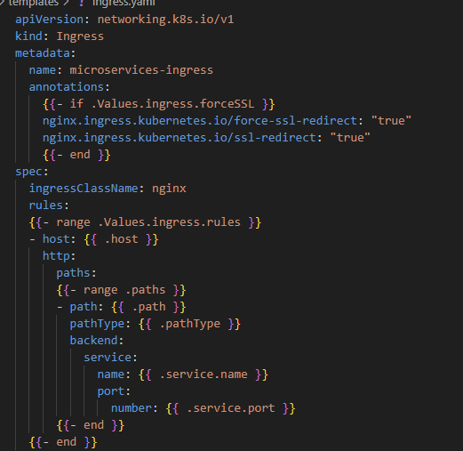

*Ingress template file*

This is the values.yaml file which is the one I use in production environment.

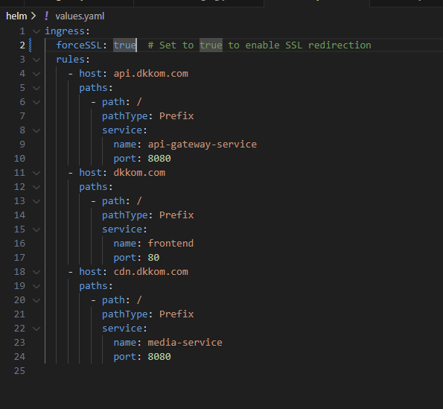

*Values.yaml file*

This is the values-staging file which contains the configuration values for my staging environment.

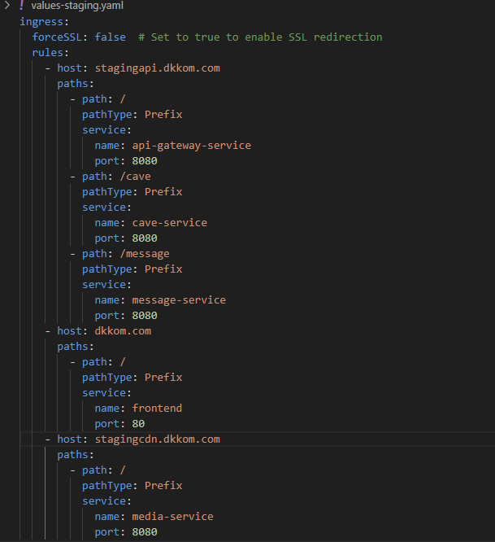

*Values-staging.yaml file*

#### Otel-collector-configmap

Otel collector is a service I have on my cluster that collects logs and metrics from the pods and sends them to google cloud to be displayed on the monitoring dashboards.

This is not the configuration of the collector service but the configuration of a file that needs to be set within the pod in order to tell the collector how to communicate with google.

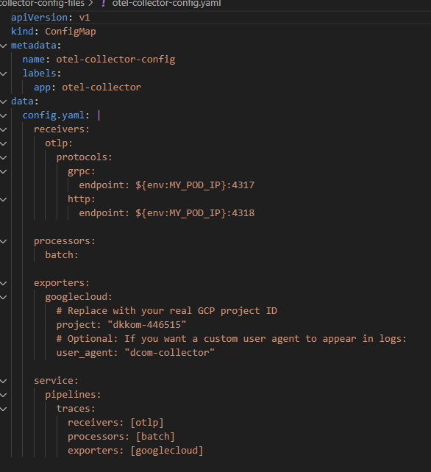

*Configmap for otel-collector*

### Service Files

Like the ingress most of these services also have template files, because of that I will show only one example of a typical set of templates for a microservice.

#### Deployment template

This is an example for a template from one of my services. This is the format the roughly all other microservices have, with the main differences being credentials, probeness values, and resource configuration.

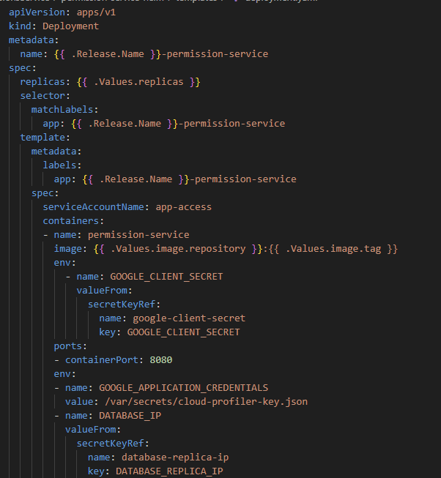

*Initial file values with an example of credentials being injected from the secret manager*

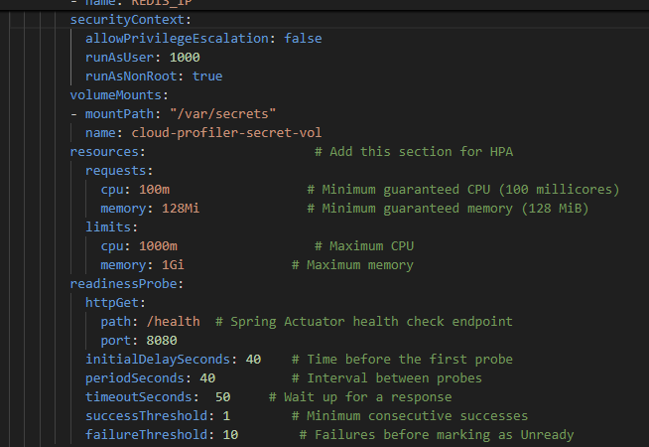

*Configuration for security context, resource limits and readinessProbe*

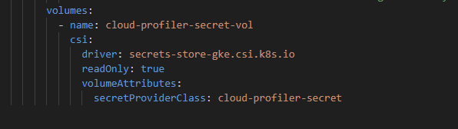

*Some secret being mounted as a volume to later be accessed within the pod*

On top of the deployment template itself there are the values that are referenced on the template. These can be found on the files “values.yaml” or “values-staging.yaml”

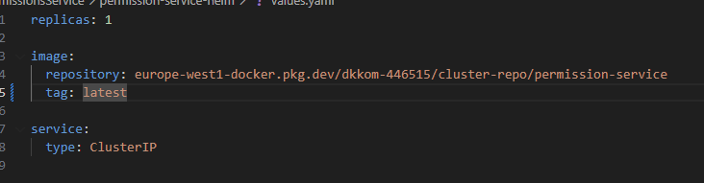

*Values.yaml (Production values)*

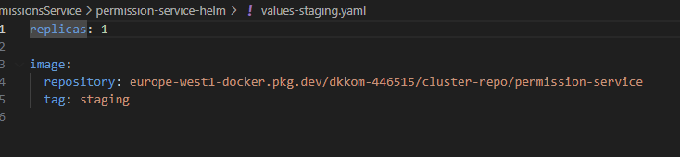

*Values-staging.yaml (Staging values)*

All the files above make the configuration for the pod configuration for a micro-service. The values file is very shallow and some of the values from the deployment template should be passed to here for better usage of helm, but since both environments use the same values, I just didn’t think it was that important, but in any case, I point it out.

#### Service template

This is the template file for creating a Kubernetes service that expose the pods to whoever they need to be exposed to. This is a very simple template but still is crucial.

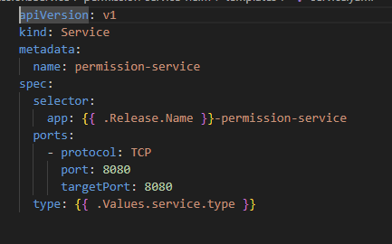

*Service template file*

#### HPA(Horizontal Pod Autoscaler) template

This is a very important template since this is the template that instructs Kubernetes how to behave for a certain pod to scale

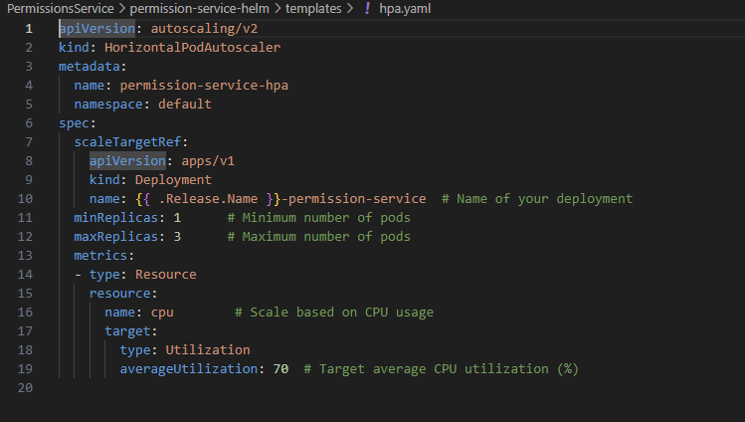

*HPA template*

#### Kafka deployment

The kafka deployment and the scylladb deployment are a bit different from the others just because they are normal deployment files without the usage of helm. This is the reason because having kafka or scylladb in the cluster is not a recommend approach anyway so there wasn’t much of a point to have any fancy setups for them since they just act as external services.

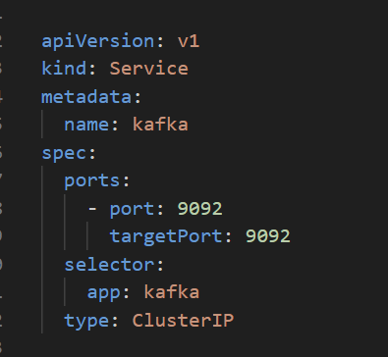 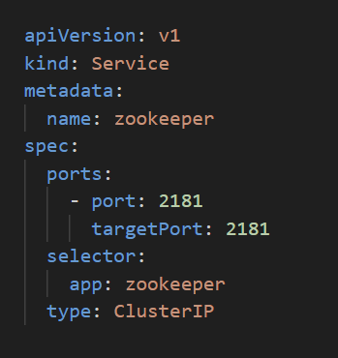

*Kubernetes services for kafka and zookeeper (kafka dependency)*

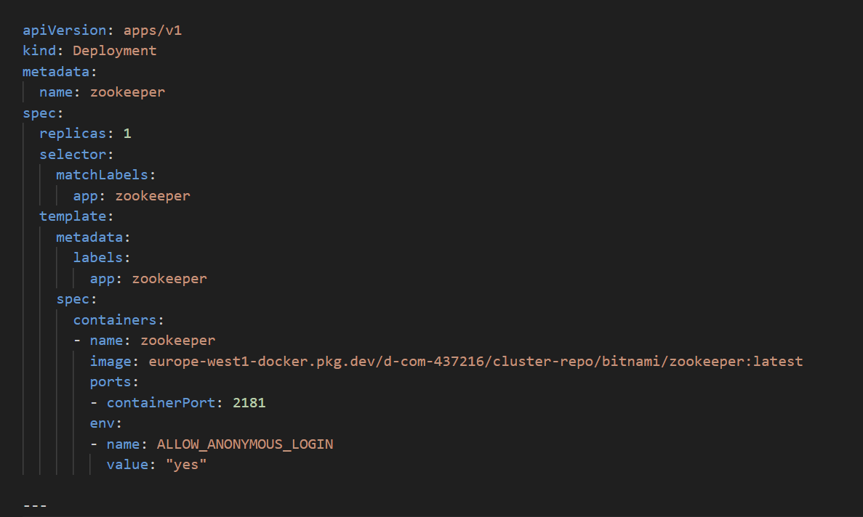

*Zookeeper deployment configuration*

A note that I would like to point out is that the kafka deployment is not a normal deployment but a stateful set the reason being because stateful set are better suited for persistence services and not much as micro-services hence being a stateful set.

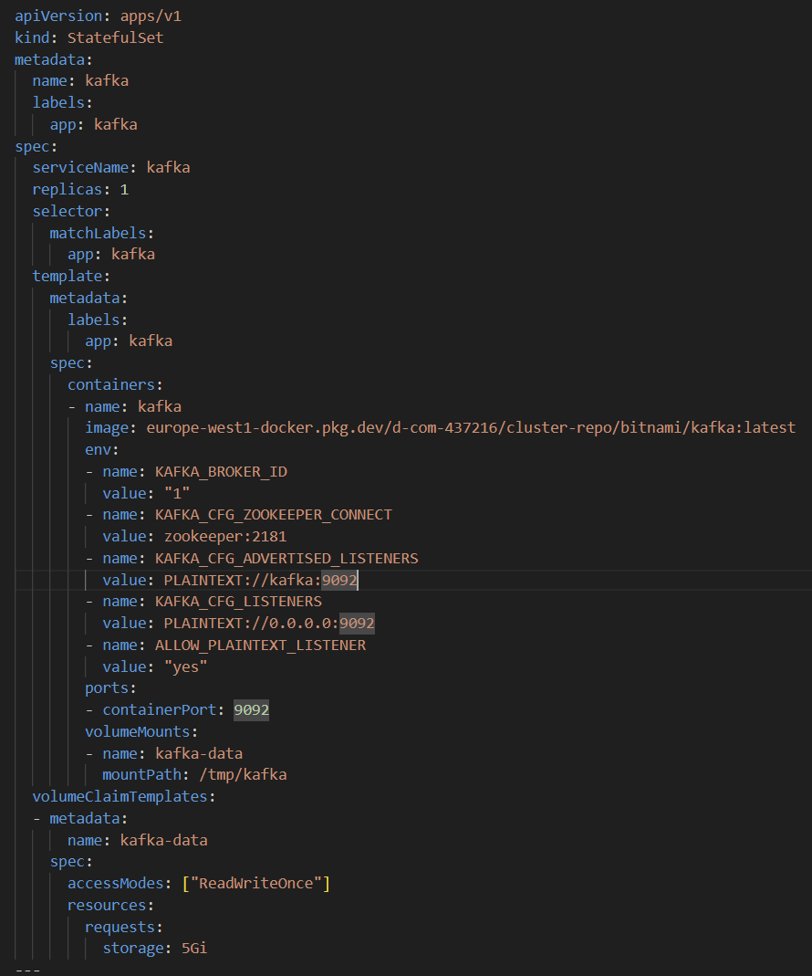

*Kafka statefulset configuration*

#### Scylladb deployment

This is the deployment configuration for my Scylla DB. A database should never be inside a cluster like this however when I first started, I needed to have it somewhere and there were no cloud services for Scylla, so I just created a deployment for Kubernetes. Currently I have proper Scylla DB with sharding but since that’s very recent I will keep this here since it belonged to the whole process this entire time.

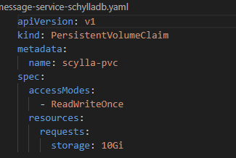

*Persistent Volume for the database*

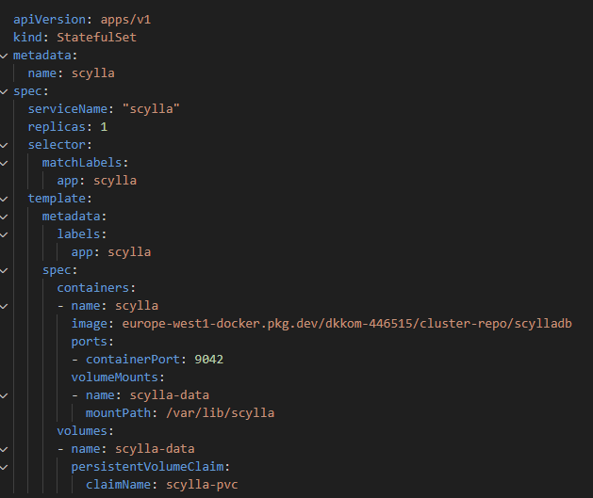

*Stateful set configuration for Scylla*

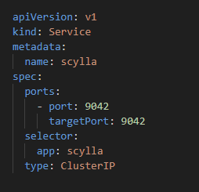

*Kubernetes Service exposing the database pods*

#### Otel-collector deployment

This the deployment configuration for otel-collector.

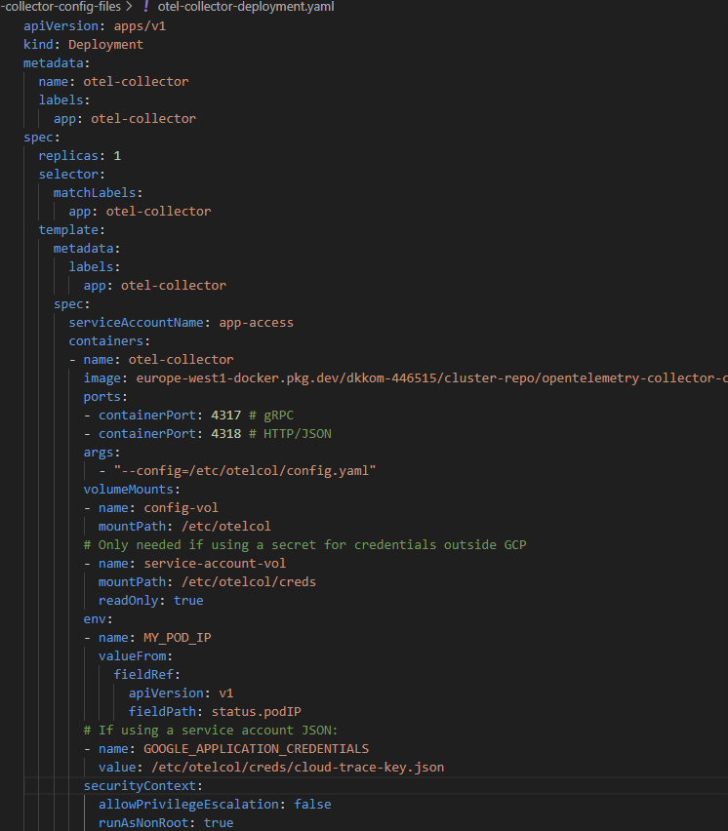

*Deployment configuration image 1*

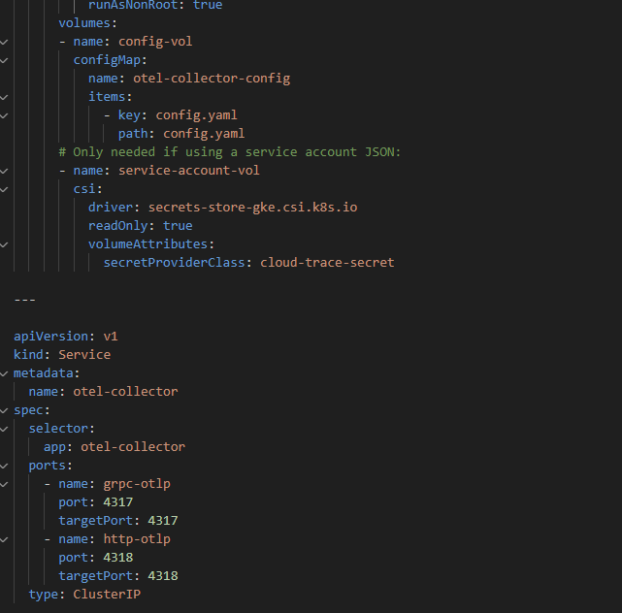

*Deployment configuration image 2*

With what I already described before with the other examples there isn’t anything new to explain here but since this is a crucial component of the observability of the system it needs to be shown.

#### Extra examples from files

As mentioned previously most templates files look the same and have small changes, in this section I will just be displaying some of them.

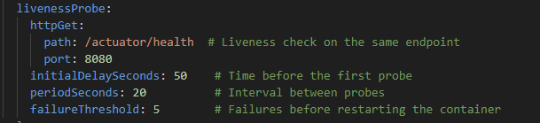

*Configuration for livenessProbe*

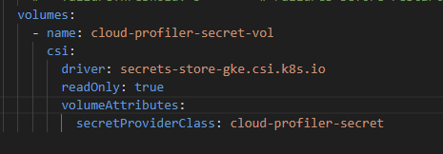

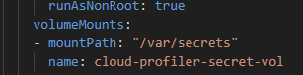

*Mounting secrets from the secret manager*

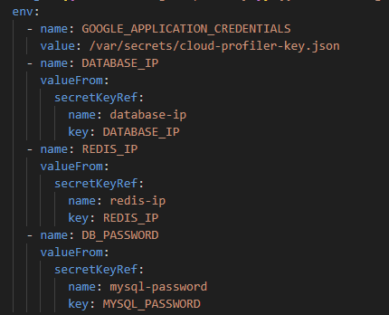

*Creating environment variables from the Kubernetes proprietary secret manager*

## Docker files

I consider the docker files an important piece of this DevSecOps process because they are what define the images that will be ran. I will separate this section into backend Dockerfiles and frontend Dockerfiles. The backend services Docker files look almost identical, while the frontend has some tweaks to it.

### Backend Service Docker files

Each service has four docker files:

* Dockerfile-prod
* Dockerfile-staging
* Dockerfile-test
* Dockerfile-run-test

Every single service has these files so I only be showing one example per file.

#### Dockerfile-prod

This docker files build the image that will be ran on the production environment. This file start from a very lightweight image with the minimum possible dependencies to run a java application. After there are three steps:

* The first is to update any package that belongs to this image in order to avoid outdated and vulnerable packages
* The second step downloads the open telemetry agent that is mounted to the application collect system metrics and enable tracing.
* The thirds step downloads the profiler that is also mounted to the application

After these steps some environment variables are set to configure the tracing agent, and the entry point is set to start the application in the production profile.

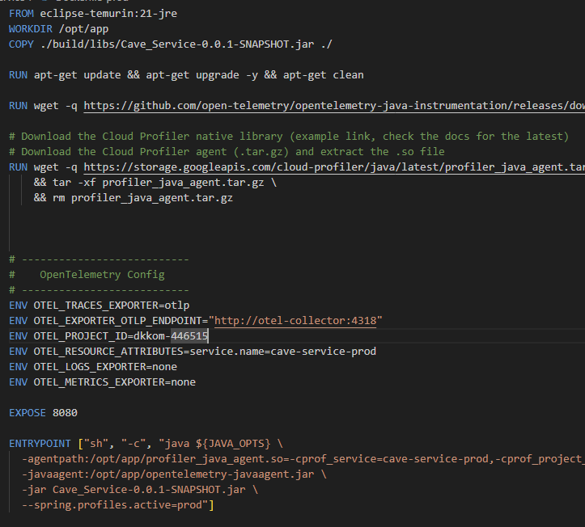

*Image configuration*

#### Dockerfile-staging

The staging Dockerfile is the same as the production one only changing the service names for the tracer, profiler, and the active profile on the application. This is the case for the tracer and profiler because their names are how the google dashboards display/identify them so if I want to run a staging environment and a production environment at the same time, they need to have different names otherwise I cannot know which data is from which environment.

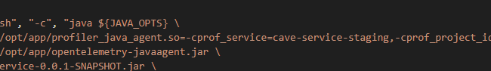

*Name property on staging docker file*

#### Dockerfile-test

The Dockerfile test is much simpler than the other two because the idea of this file is building an image that will be used to create a container on a testing environment. This test environment is all built with docker containers and is not integrated in the cloud so there is not the need for much more configuration.

*Dockerfile test contents*

#### Dockerfile-run-test

This dockerfile might seem similar to the previous becaues of the name but they are very different. The previous one create a container for the application with the test profiler active. This dockerfile is used to create a image that when turned into a container will run tests for the application.

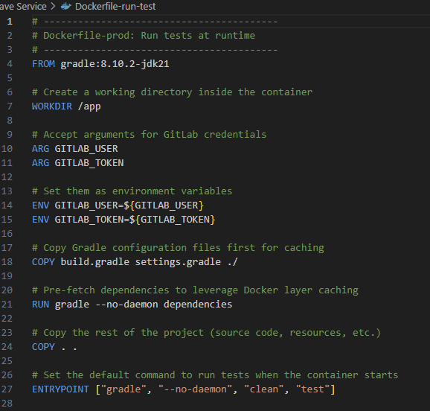

*Docker file*

### Frontend Docker files

For the frontend there are two files:

* Dockerfile-prod
* Dockerfile-staging

Like the backend docker files these also configure the frontend for a staging or production environment.

#### Dockerfile-prod

This docker file has the following steps:

* Install dependencies
* Build app for production
* Copy the build to a new nginx image template
* Copy the nginx configuration to the image
* Specify startup command.

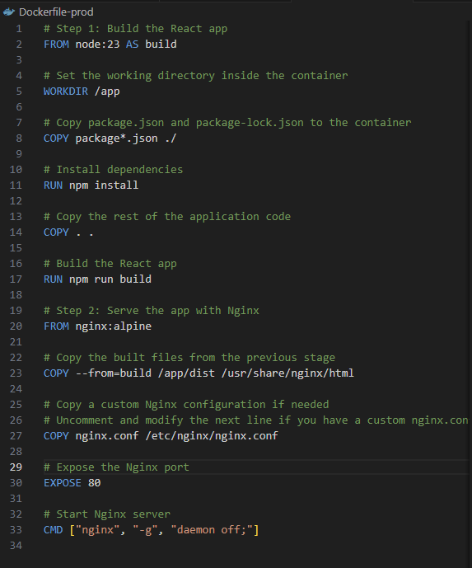

*Dockerfile prod*

#### Dockerfile-staging

The staging image is almost the same as the production, the only change is that the build step is triggered to build with staging variables instead of production ones.

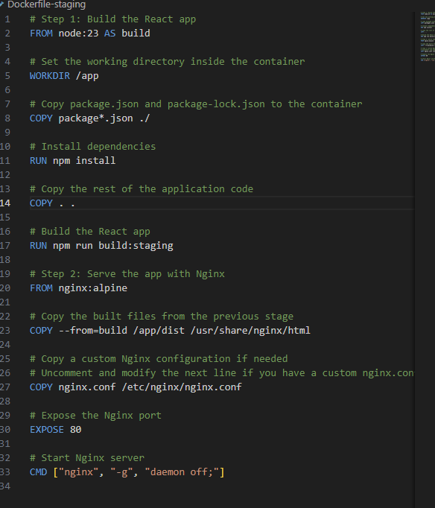

*Dockerfile staging*

## Jenkins

The main component for the pipeline is Jenkins, being the automation tool handling the process. Before going into a breakdown of the jobs I’m running I want to point out that Jenkins is holding all the required credentials to run the jobs and deals with the injection at runtime. Currently I also have two Jenkins agents, one is the agent that runs the Snyk tests for library vulnerabilities, and the other is the test environment agent where the test environment for the system is set and where each service runs its tests.

The virtual machine where Jenkins is running also has some installed packets that it needs to perform some of the stages of the pipelines, these are:

* Google cloud cli: For the cloud commands.
* Terraform: Terraform to run the terraform scripts.
* Docker: To create and push the images.
* Helm: Kubernetes packet manager.
* Kubectl: CLI to interact with the Kubernetes cluster.

### Jobs

Within Jenkins I have the following jobs:

* Api gateway
* Cave-service
* Cloud infrastructure
* Dcom
* Frontend
* Media service
* Message service
* Performance-test-setup
* Permission service
* User presence service
* User service
* Websocket gateway

Most of these jobs are there to build-test-deploy the services but there are some outliers like the cloud-infrastructure and performance-test-setup. These will be explained in detail, but they do what their name suggests.

For the following explanations I won’t be going through all jobs related to services because they all follow the same structure.

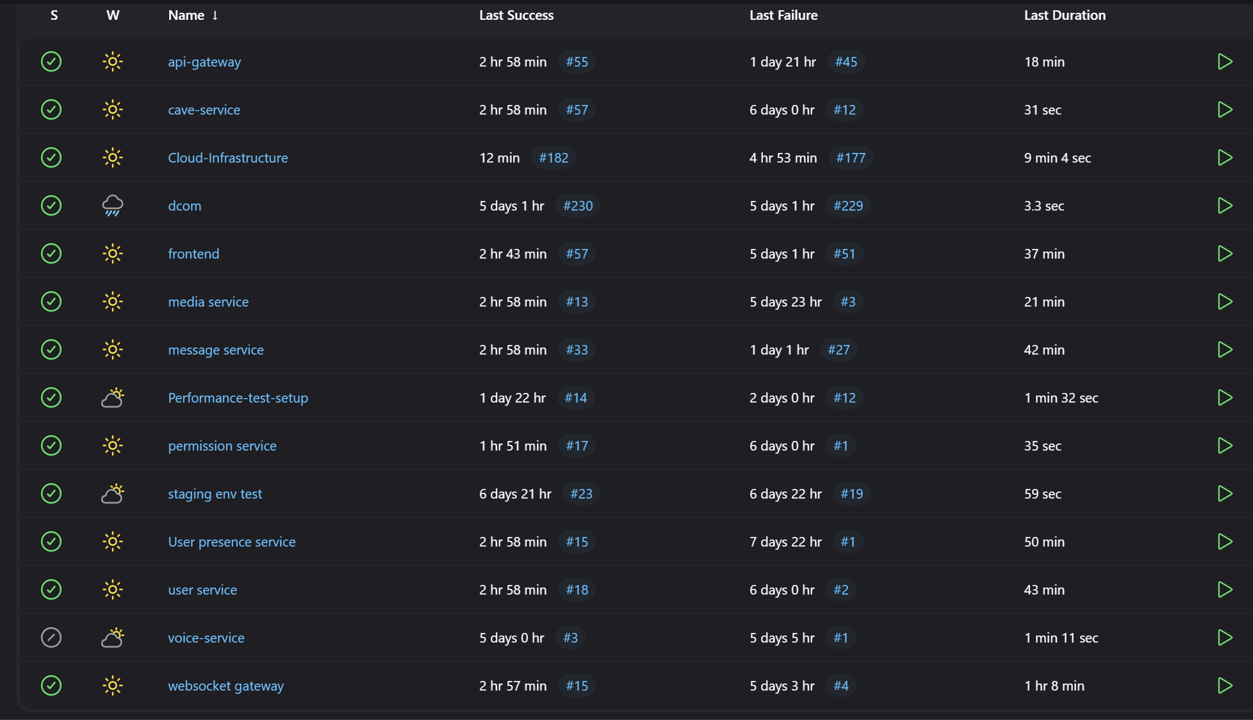

*Job list*

#### Cave-service

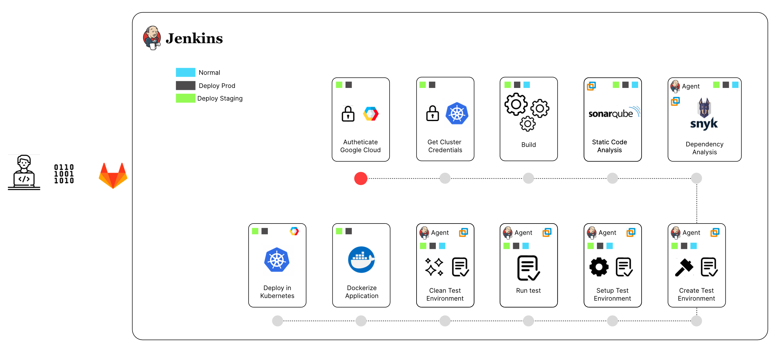

*Diagram of pipeline of all options*

This will be example for a service job. The job has three possible options trigger different aspects of the job. I would like to have these trigger options separated into different jobs but because I have storage constraints with the Jenkins VM I can’t go too far with the jobs because otherwise I would.

The options are:

* Normal
* Deploy staging
* Deploy prod

The deploy options contain all the normal stages.

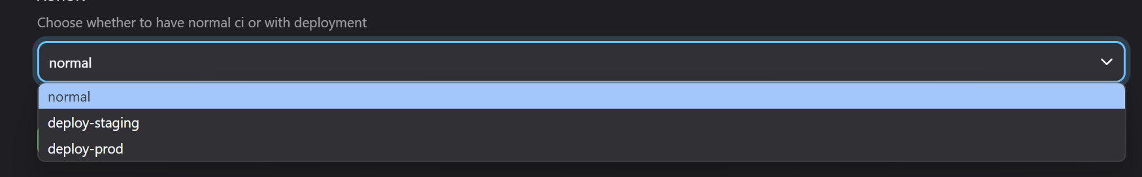

*Job options*

##### Normal

The normal option runs the pipeline for build – test – scan but does not deploy the service.

The stages are:

* Build: This is just a very simple step that builds the application without running tests.

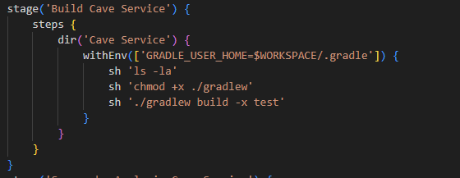

* SonarQube analysis: This stage runs the SonarQube analysis for the application

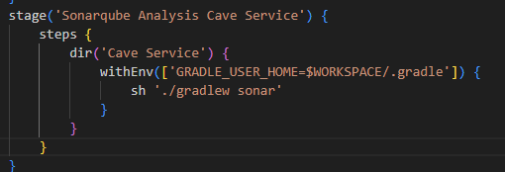

* Snyk Analysis: This stage runs on the Snyk agent and runs the Snyk analysis on the project.

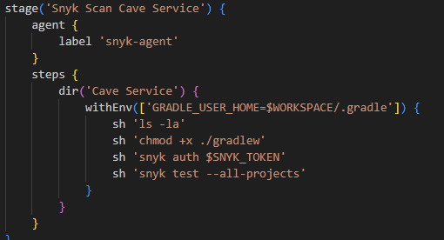

* Create test environment external services: This stage is where thing start to get more complex. On this stage I setup docker containers for external services like databases and configure them if they need it which is the case for the MySQL container and the Scylla db.

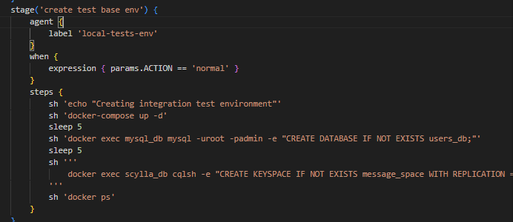

* Setup Services for the test environment: In this stage I create docker containers for all the other services besides the one that is being ran, so if I’m running this cave-service job I will create containers for all the other services but not this one. This is the step where the Dockerfile-test is used.

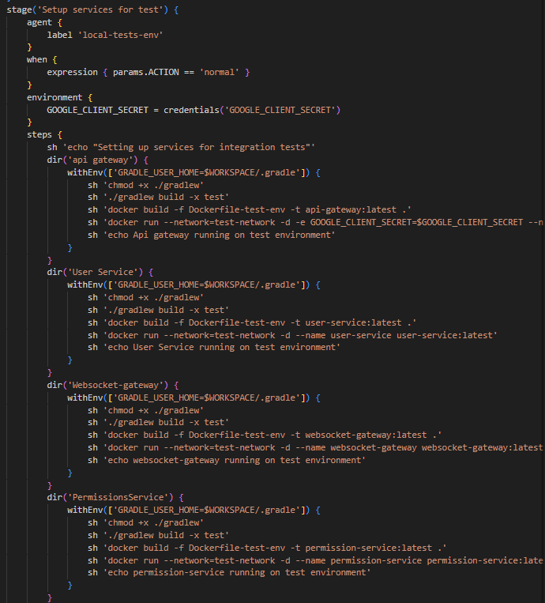

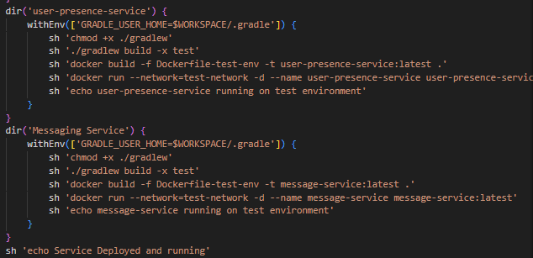

* Run tests: in this stage I run the tests for the service. This is where I make use of the Dockerfile-run-test to build the image that will turn into a container and run the tests with the entire testing environment setup. In this step I also a little bit of clean up by removing the image that was just created.

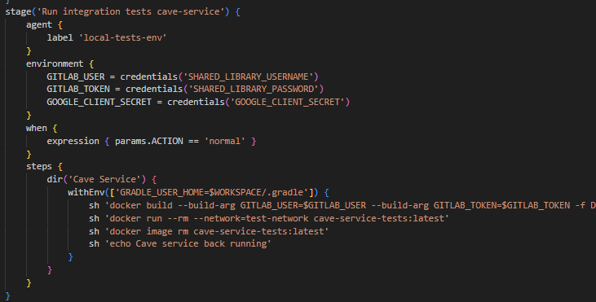

* Clean the test environment: In this stage I clean up the whole environment by removing any containers or images. The reason this stage exists is because as I mentioned before I don’t have a lot of space on the Jenkins master node and all these docker images and containers occupy a significant amount of space if ran multiple times hence why I clean everything after every test run.

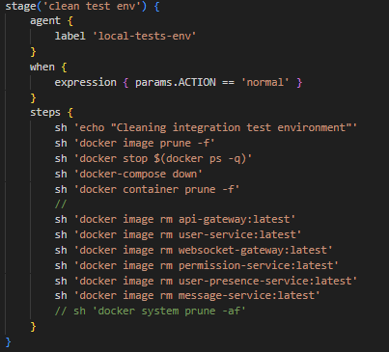

##### Deploy prod

Deploy prod contains all the stages from the normal but it also has the steps for deployment that are:

* Authenticate with Google Cloud: This stage authenticates with google cloud in order to interact with the cloud environment.

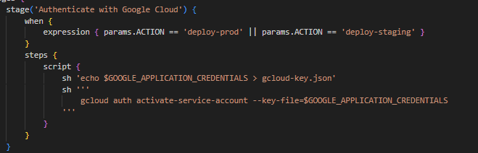

* Get Cluster Credentials: This stage fetches the Kubernetes cluster credentials and will be used to apply the deployment.

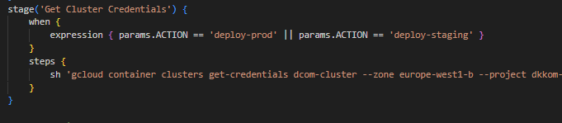

* Dockerize Service Production: In this stage I build the docker image and push it to the remove repository.

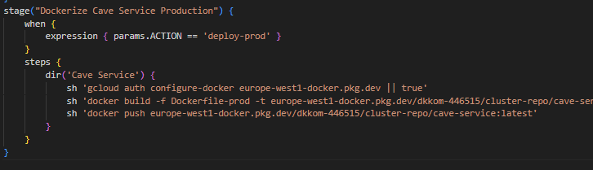

* Deploy Service Production: In this stage I make use of helm to install the service deployment with the production values

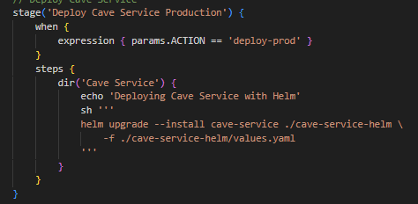

##### Deploy staging

The deploy staging has the same stages has the prod with the main difference being the:

* Dockerize Service staging: the difference from the production option is that here I tag the image differently.

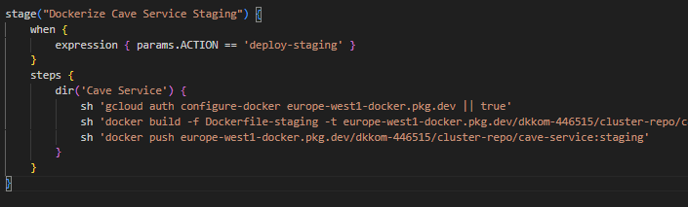

* Deploy service staging: Here I install the service but using the staging values.

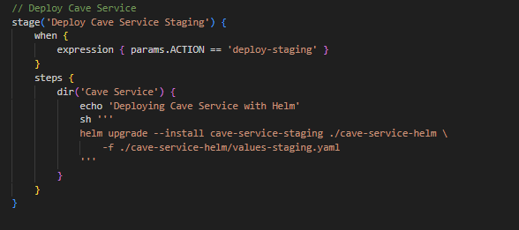

These options and stages are the same throughout all the other services.

#### Cloud infrastructure Job

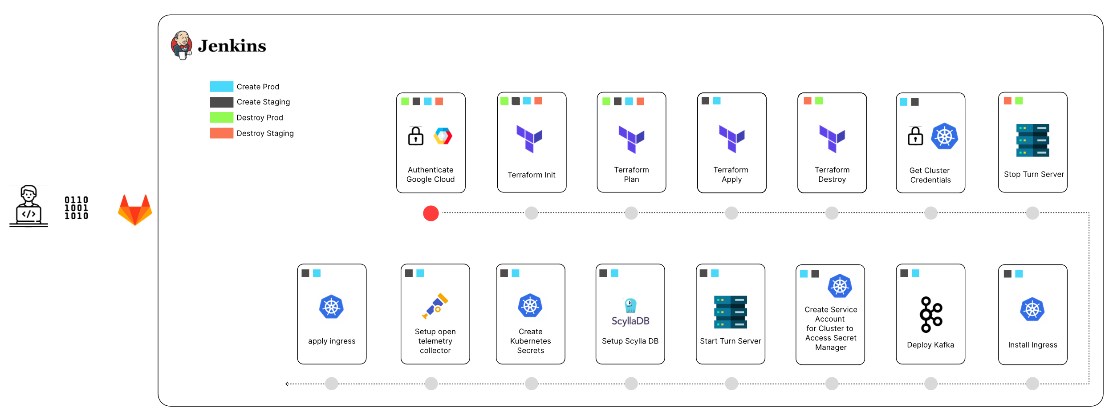

Due to costs, I don’t have the cloud environment running 24/7 and it still takes some effort to manually setup everything, so I created this job that has two functionalities, to setup the cloud resources and to destroy them. This job is marked with four options:

* Create prod
* Destroy prod
* Create Staging
* Destroy Staging

Like the service one If I had more Jenkins storage, I would have a separate job for each or at least separate the production from the staging.

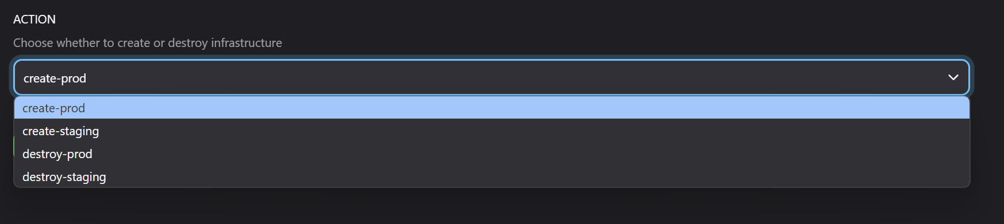

Before going into the options, I would like to point out that the terraform files are mentioned but not explained, instead this explanation can be found on the terraform file.

##### Create prod

The create prod option is responsible for triggering the stages that create cloud production environment, this option is composed of the following stages:

* Authenticate with Google cloud: as shown before this stage I authenticate with the google platform.
* Terraform init Production: in this stage I start the terraform process with the required environment variables.

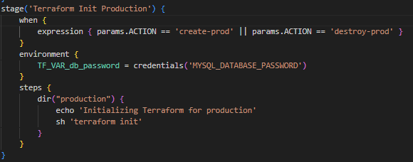

* Terraform Plan Production: This stage displays the terraform plan for the resource creation.

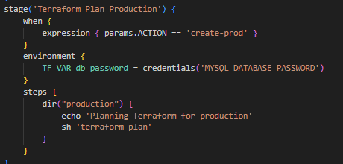

* Terraform Apply production: this stage I apply the terraform plan but also have this script section which is one of the reasons why I like Jenkins so much. Some of the resources I create with terraform have dynamic IPS which means that every time I ran terraform there is a chance the IPS for these components are different. To address this, I have the following:

This snippet of my terraform file exports the IPS once the resources were generated.

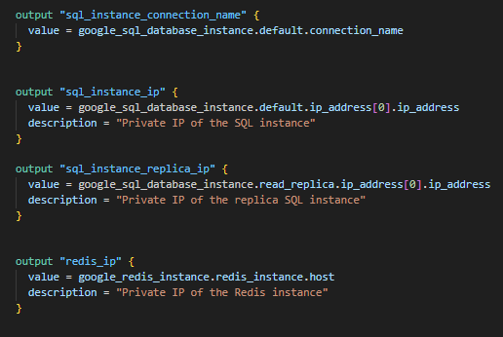

This script portion of the stage picks up that output from the standard output and stores the values as environment variables for the job that will later be used to create Kubernetes secrets that are used by the applications.

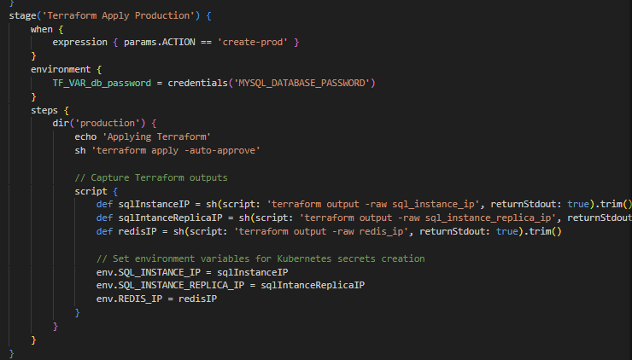

* Get Cluster credentials: This step was also already explained previously.
* Install ingress: In this stage I install the nginx ingress controller on my cluster.

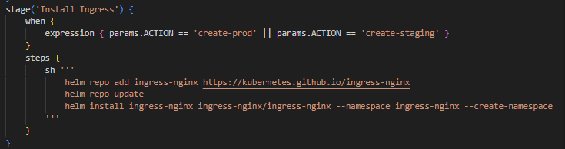

* Create Service Account for Cluster to Access Secret Manager: In this step I create a service account and create bindings from that account to the services I want to import into the cluster. This configuration is what allows for the cluster to mount secrets from the secret manager into the pods. The setup for this intricated feature can be found here ([Google Tutorial](https://cloud.google.com/secret-manager/docs/secret-manager-managed-csi-component?authuser=2&_gl=1*6ydnzq*_ga*MTQzMTgxMTgxMy4xNzI3MjkzMjUw*_ga_WH2QY8WWF5*MTczMjU1MjIwNi45Ny4xLjE3MzI1NTUxMTUuNDUuMC4w)).

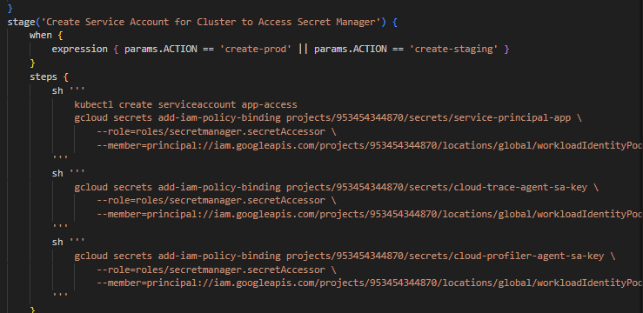

* Deploy kafka: In this stage I apply the configuration for kafka.

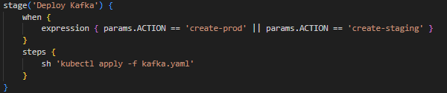

* Start turn server prod: This stage turns on the turn server which is a critical component of the voice communication infrastructure.

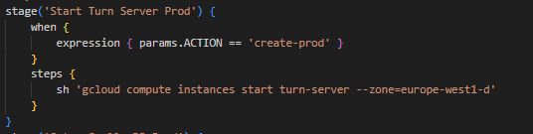

* Setup Scylla DB prod: This is a very tricky stage because in here I setup a Scylla DB cluster with two shards. This setup at its core is an automation of this Scylla DB [setup guide](https://www.scylladb.com/download/?platform=debian-11&version=scylla-6.2#open-source). However, part of this setup is also on the terraform file so if that is required, I encourage to check out the terraform word document. In real world scenario this would be its own job with more complex stages and most likely this Scylla DB cluster would be a cloud managed resource so none of this setup would be required, but since sharding is a learning experience I wanted to do it myself.

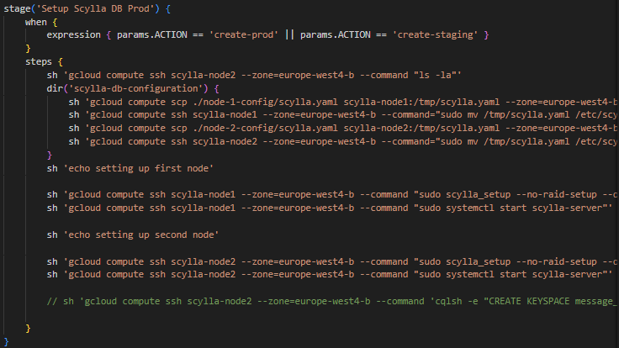

* Create Kubernetes secrets: In this stage I create all the Kubernetes secrets that are required, all these secret values are injected by Jenkins, and they are pulled from the Jenkins credential manager.

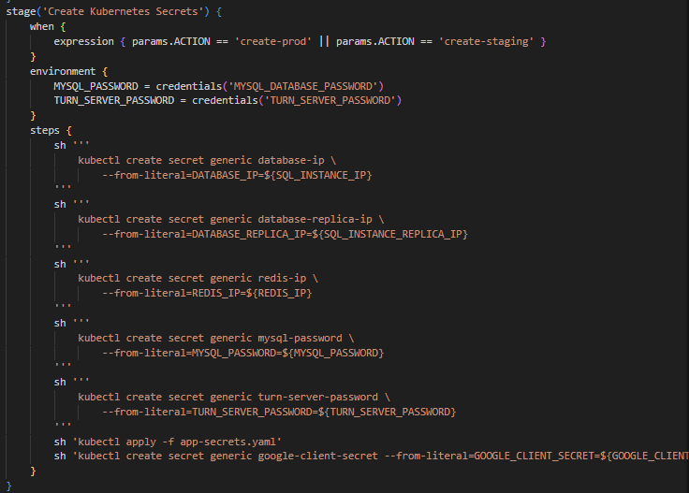

* Setup open telemetry collector: In this setup I apply the deployment configuration from the Otel collector.

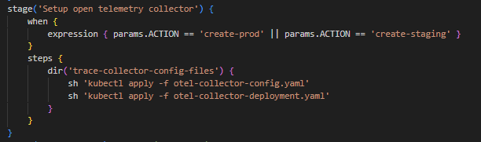

* Delay stage: this stage is here to give some time for every configuration to settle in.

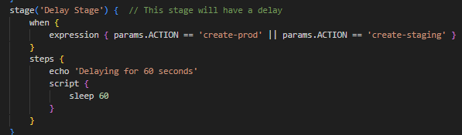

* Apply ingress production: As a last step of this job, I apply the ingress controller configuration. All the explanation and values for this configuration can be found on the Kubernetes files section of this document.

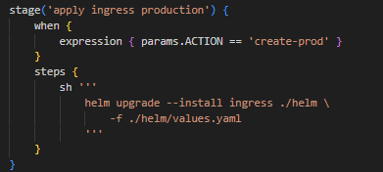

At this point the pipeline succeeded but I still need to do a final manual step. The Kubernetes cluster now has an ingress, but the IP is dynamic so for every time I start this cloud environment the IP will most likely be different than the previous time, so as a final step I need to go to Cloudflare to change the DNS records to point to this new IP.

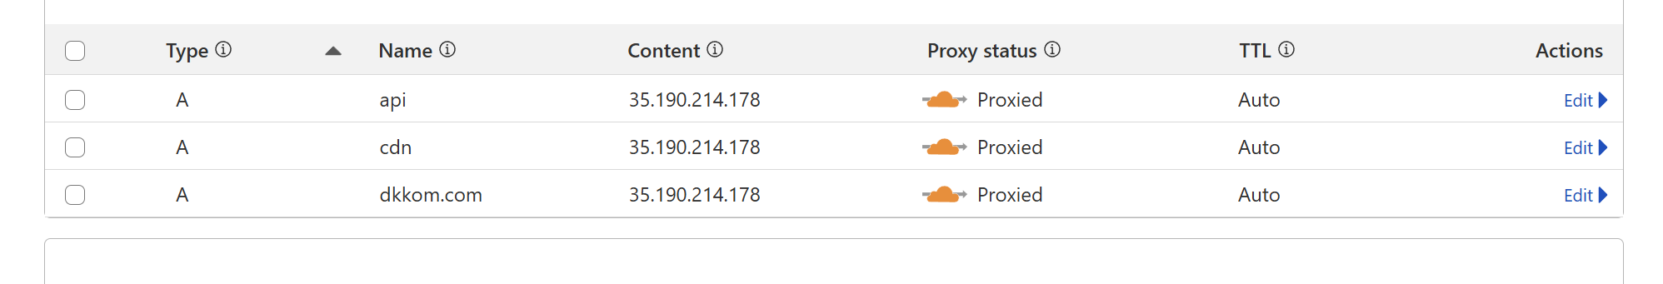

##### Create Staging

The create staging option shares all the stages the create prod has but some of the stages differ to apply staging related values.

Staging option stages:

* Authenticate with Google Cloud
* Terraform Init Staging
* Terraform Plan Staging
* Terraform Apply Staging
* Get Cluster Credentials
* Install Ingress
* Create Service Account for Cluster to Access Secret Manager
* Deploy Kafka
* Setup Scylla DB Prod: I borrow this stage from the production option. As mentioned before this section on the document I have a message-scylla-db deployment that creates a Scylla DB inside the cluster, however at a certain point I created this more complete setup and stopped using the deployment file for the Scylla on the production environment. This later changed where I also started using this for the staging environment as well.
* Create Kubernetes Secrets
* Setup open telemetry collector
* Delay Stage
* Apply ingress staging: the only thing that differs here is the command to set the staging values.

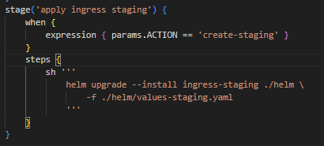

Like the previous option at the end of this pipeline I still need to manually go to Cloudflare and update the required DNS records 

##### Destroy prod

This option is way simpler than any of the previous ones and its job is to simply destroy the entire production environment.

The stages are:

* Authenticate with Google Cloud
* Terraform Plan Production
* Terraform Destroy Production: In here I apply the destroy command from terraform.

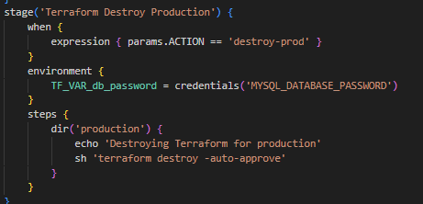

* Stop Turn Server Prod: In this stage I stop the turn server. I don’t destroy it because the turn server is something that I prefer to have just turned off because of the tricky configuration that goes behind it.

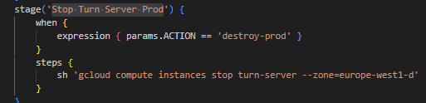

##### Destroy staging

This option goes through the same stages the destroy prod does.

#### DCOM Job

This job was my main job before I split everything into per service jobs. The goal of this job was to run every service in one go, this made job time gigantic, but it made sense the reason for that. However funny enough this job got so big that Jenkins no longer accepts the pipeline file to run this job. As a sum up every step in this job is identical to the service job but multiplied for all services. Also, in this job the test environment is handled a bit differently since I don’t need to destroy it per service and can destroy it at the end of the entire job.

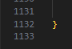

*Job lines*

#### Frontend Job

This job Is responsible for deploying the frontend. The frontend job is very similar to the “Service job” one.

This job is also composed of the same three options the service job has:

* Normal
* Deploy prod
* Deploy staging

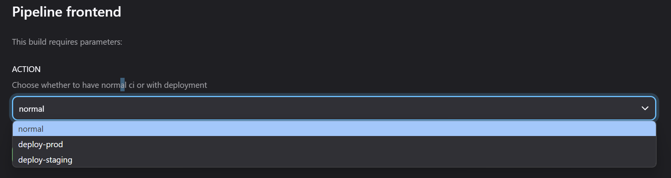

I won’t be repeating myself through the steps since there is no added value so I will just mention them.

The job is composed of the following stages:

* Authenticate with Google Cloud (deploy)
* Get Cluster Credentials (deploy)
* Build frontend
* Snyk Scan frontend
* Dockerize
* Deploy

## Setup

In this section I will be going through the setup of all components that compose the pipeline.

### Jenkins Server

#### Jenkins

First, we start with Jenkins, since Jenkins is running on a VM the first thing we need to do create a VM.

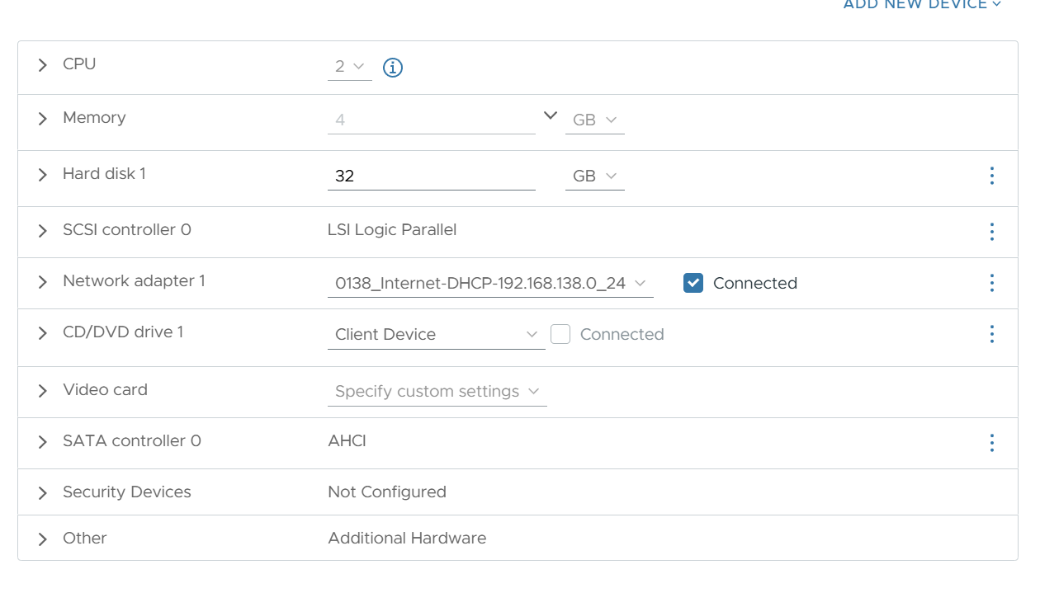This is an ubuntu 2024 template from netlab.

I have Jenkins running as a standalone process so there is not docker involved. This means that we need to install the dependencies Jenkins relies on, this mainly being java.



“apt install openjdk-21-jdk”

Once we java installed, we need to add the Jenkins repository to our machine since it’s not “public” out-of-the-box.



“wget -q -O - https://pkg.jenkins.io/keys/jenkins.io.key | sudo apt-key add –“



“sh -c 'echo deb http://pkg.jenkins.io/debian/ stable main > /etc/apt/sources.list.d/jenkins.list'”



“wget -O /usr/share/keyrings/jenkins-keyring.asc <https://pkg.jenkins.io/debian-stable/jenkins.io-2023.key>”



“echo "deb [signed-by=/usr/share/keyrings/jenkins-keyring.asc]" https://pkg.jenkins.io/debian-stable binary/ | sudo tee /etc/apt/sources.list.d/jenkins.list > /dev/null”

Now that we have the repository configured, we update our repositories so that we can after fetch Jenkins.



“sudo apt-get update”

Now we can simply run:



“apt-get install jenkins”

Now just to make sure that Jenkins is running we run:



“systemctl start Jenkins”



“systemctl enable Jenkins”

At this point Jenkins should be installed and running but it’s still not accessible to the network for that we just need to allow the firewall to receive connections on port 8080 (Jenkins default port).



“ufw allow 8080”

Now we can just go to the IP of the machine with port 8080 and Jenkins UI setup should appear. Unfortunately, I don’t have the pictures of me following the setup but it’s very straightforward.

#### Google cloud cli

The Jenkins Server is not composed only be Jenkins it also has another tool that need to be installed to be used by the jobs, one of these being the google cloud cli. The following steps are also illustrated in ([g-cloud cli install](https://cloud.google.com/sdk/docs/install))

Like Jenkins we need to setup the google repo for getting the cli program.



“curl -O https://dl.google.com/dl/cloudsdk/channels/rapid/downloads/google-cloud-cli-linux-x86_64.tar.gz”

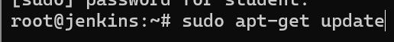

“sudo apt-get update”



“sudo apt-get install -y apt-transport-https ca-certificates gnupg”



“echo "deb [signed-by=/usr/share/keyrings/cloud.google.gpg] https://packages.cloud.google.com/apt cloud-sdk main" | sudo tee -a /etc/apt/sources.list.d/google-cloud-sdk.list”



“curl https://packages.cloud.google.com/apt/doc/apt-key.gpg | sudo tee /usr/share/keyrings/cloud.google.gpg”



“sudo apt-get update && sudo apt-get install google-cloud-cli”

After this google cloud should be installed.

Now that we have gcloud cli we also need to install the auth plugin to allow for authentication via the cli.

To do that we only to run the following:



“sudo apt-get install google-cloud-cli-gke-gcloud-auth-plugin”

#### Terraform

Terraform is another tool that I had to install because the Jenkins job needs this to run the terraform script.

In here we also need to add the hashcorp repository to the VM.



“sudo apt-get update && sudo apt-get install -y gnupg software-properties-common”



“wget -O- https://apt.releases.hashicorp.com/gpg | gpg --dearmor | sudo tee /usr/share/keyrings/hashicorp-archive-keyring.gpg > /dev/null”



“gpg --no-default-keyring --keyring /usr/share/keyrings/hashicorp-archive-keyring.gpg --fingerprint”



“echo "deb [signed-by=/usr/share/keyrings/hashicorp-archive-keyring.gpg] \”



“https://apt.releases.hashicorp.com $(lsb_release -cs) main" | sudo tee /etc/apt/sources.list.d/hashicorp.list”



“sudo apt update”

After this terraform should be installed.

#### Kubectl

Kubectl is the tool used by the jobs to interact with the cluster on google cloud.

For installing kubectl cli we need to do the following:



‘curl -LO [https://dl.k8s.io/release/**$(**curl -L -s https://dl.k8s.io/release/stable.txt**)**/bin/linux/amd64/kubectl](https://dl.k8s.io/release/$(curl%20-L%20-s%20https://dl.k8s.io/release/stable.txt)/bin/linux/amd64/kubectl)’



“sudo install -o root -g root -m 0755 kubectl /usr/local/bin/kubectl”

After this quick installation kubectl should be available to use.

#### Helm

Helm is a Kubernetes package manager, and I use it to install the ingress controller into the cluster.

To install the client, we can download their official installation script:



“curl -fsSL -o get_helm.sh <https://raw.githubusercontent.com/helm/helm/main/scripts/get-helm-3>”



“chmod 700 get_helm.sh”



“./get_helm.sh”

After this helm should be successfully installed.

#### Node

As one last dependency we need to install node to allow Jenkins to build the frontend.

For that we do:



“curl -fsSL https://deb.nodesource.com/setup_23.x -o nodesource_setup.sh”



“sudo -E bash nodesource_setup.sh”



“sudo apt-get install -y nodejs”

After this node will be installed.

#### Jenkins Agent

The final thing that needs to be setup related to Jenkins is the agent I’m using to run snyk. Snyk itself is installed in a different VM however for me to run the snyk analysis on the code from the repository I could “scp” the folder into the snyk vm and run the run commands, or I could add the VM as a Jenkins agent and this transferring process becomes automatically managed by Jenkins.

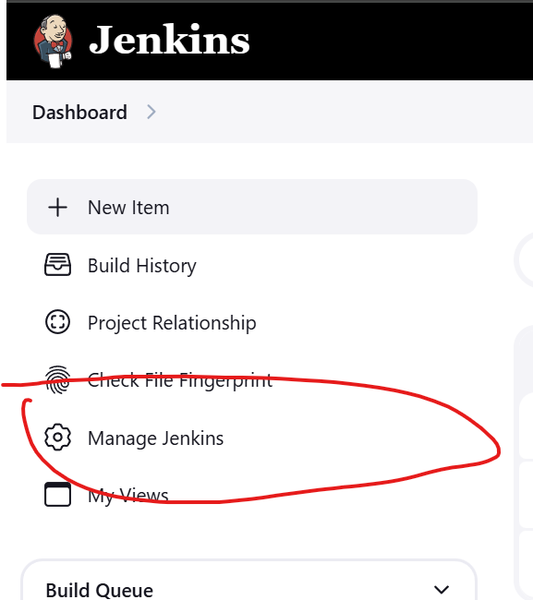

First, we go to the “Manage Jenkins” menu

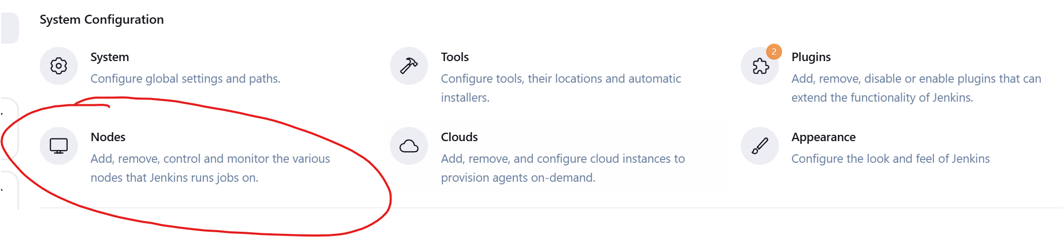

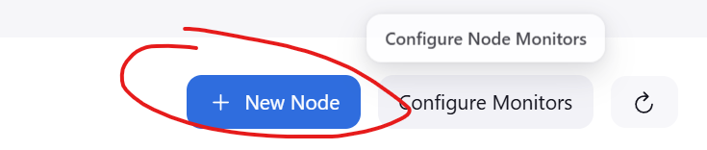

After, we select nodes and click on “New Node”.

Then we configure the node with the following options:

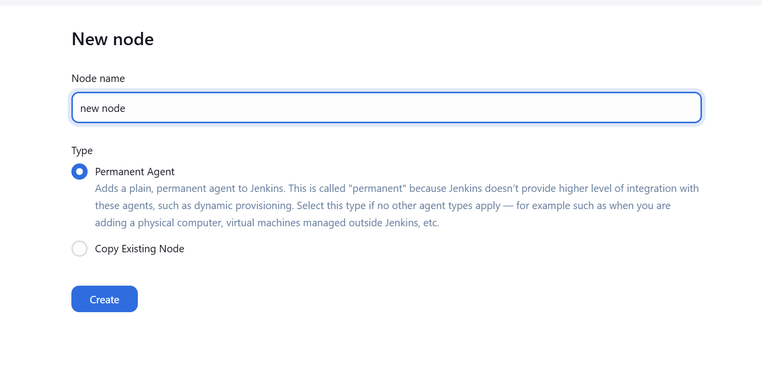

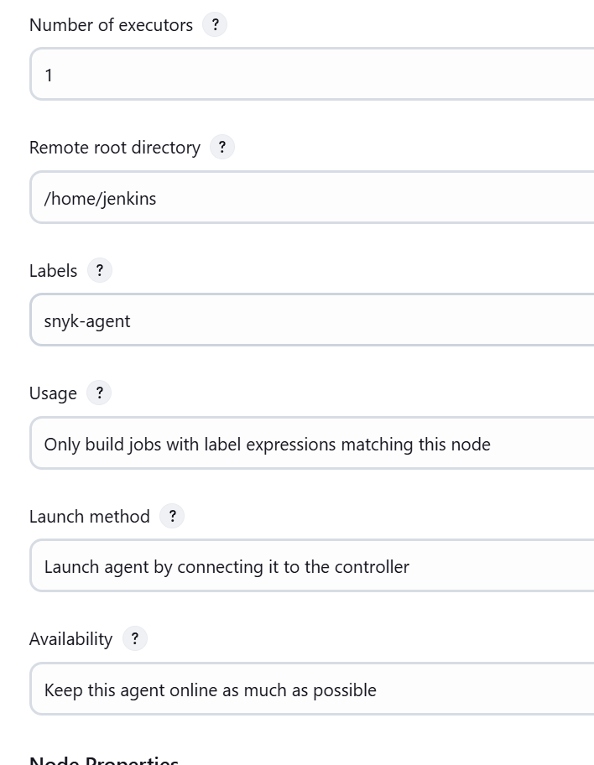

This node is going to connect to the master Jenkins node via a provided java connector (SSH is also an option, but this is faster). Also important is that this agent is only supposed to be triggered when specified in the pipeline and not whenever is available.

After Jenkins provides the following commands to be run on the agent VM.

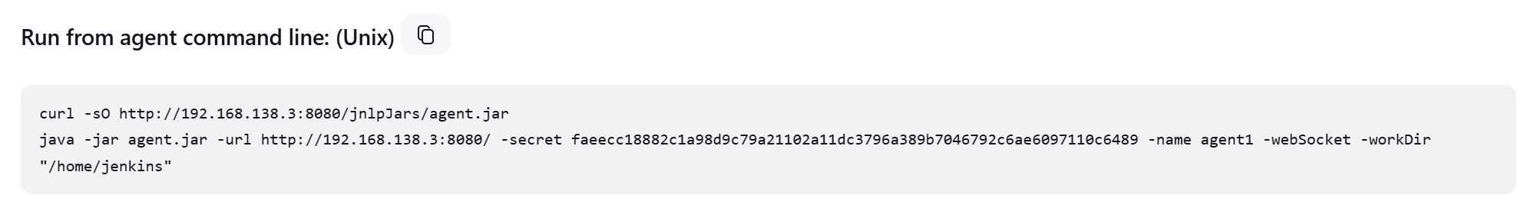

Once the commands are run, we can go back to the UI and see the status.

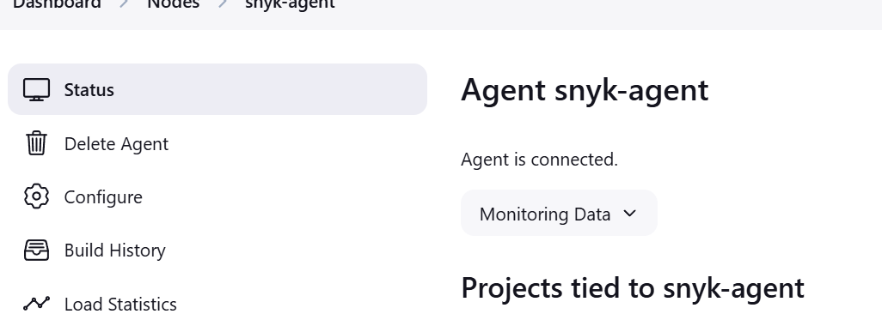

### SonarQube VM

SonarQube is SAST tool I use to analyze my backend services code. Currently this SonarQube server is running on its own VM in netlab. To setup this VM is way less troublesome than Jenkins.

In here I’m running SonarQube in docker so the only thing we need to do is run the container:



“docker run -d --name sonarqube -p 9000:9000 -e SONAR_ES_BOOTSTRAP_CHECKS_DISABLE=true sonarqube:latest”

After the container is running, we just need to allow connections to port 9000 (SonarQube Port).



“ufw allow 9000”

Now with SonarQube installed we can create projects within SonarQube for the backend services. The following process is the same for all services.

First we create a local project:

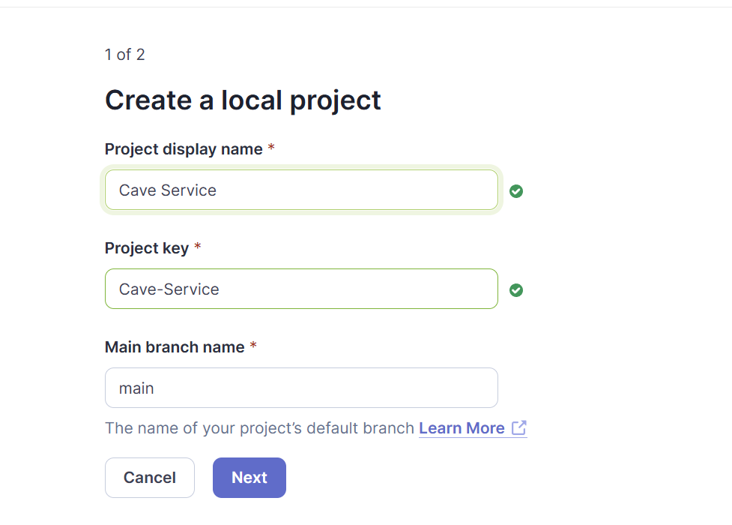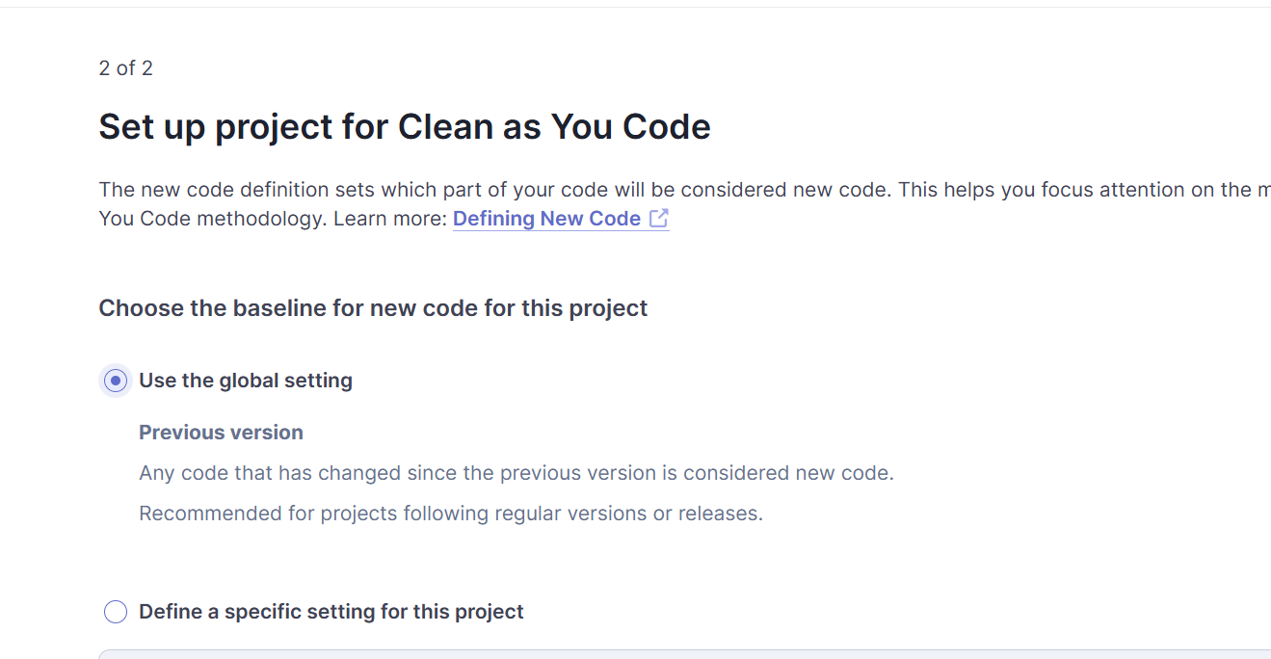

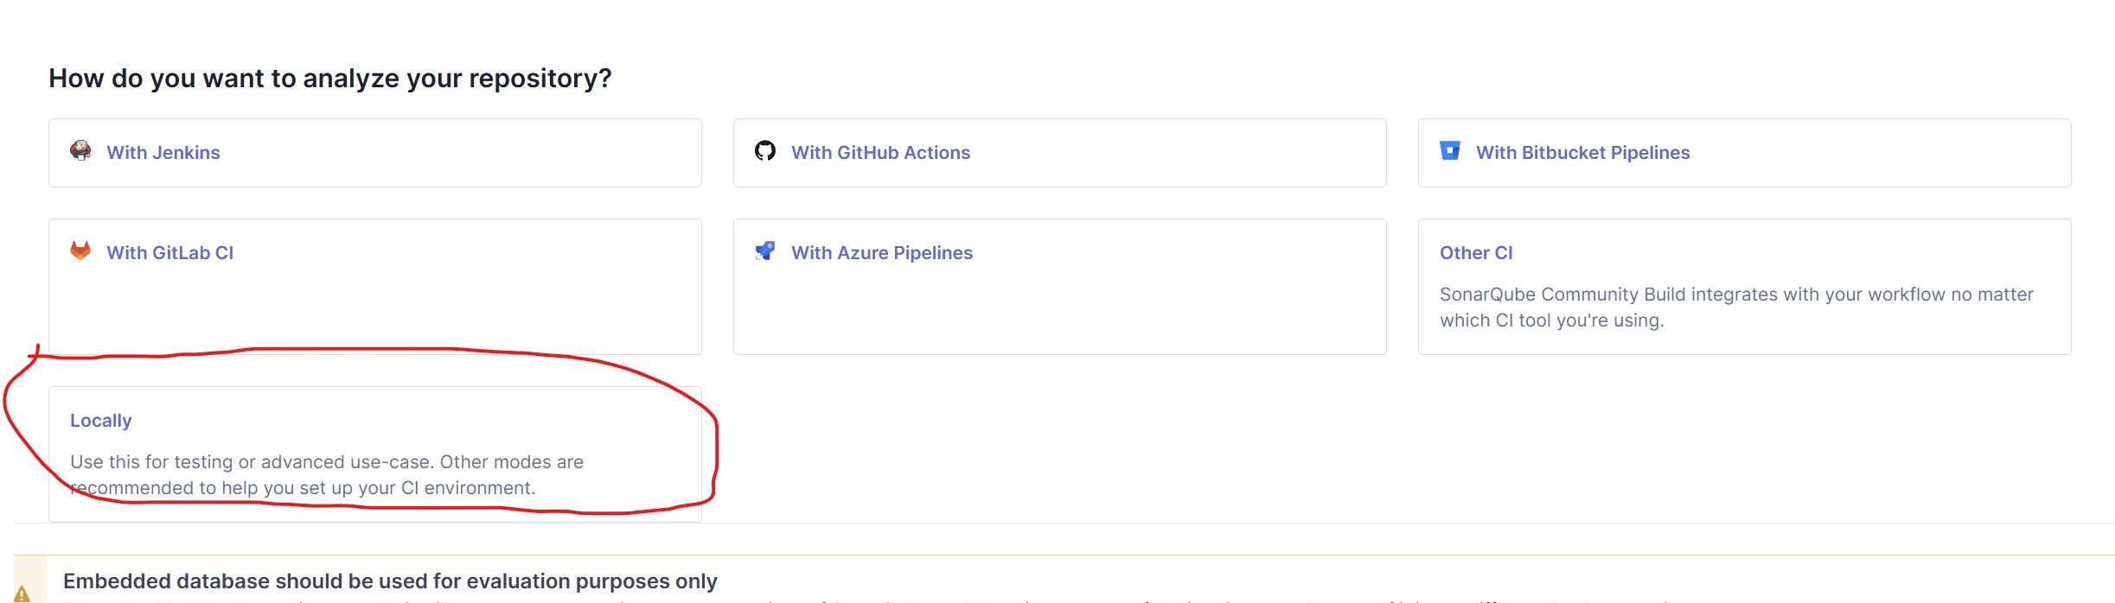

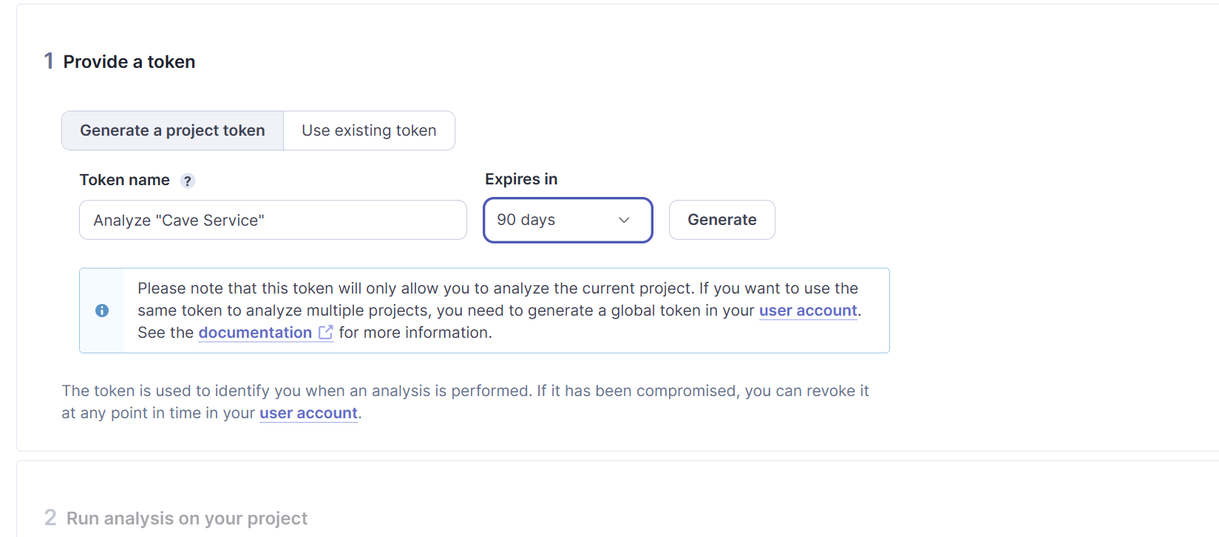

Now we need to setup our application to communicate with this server. SonarQube suggests adding the plugin to the “build.gradle” file and then run the below commands in the command line. In my case I do it a bit differently.

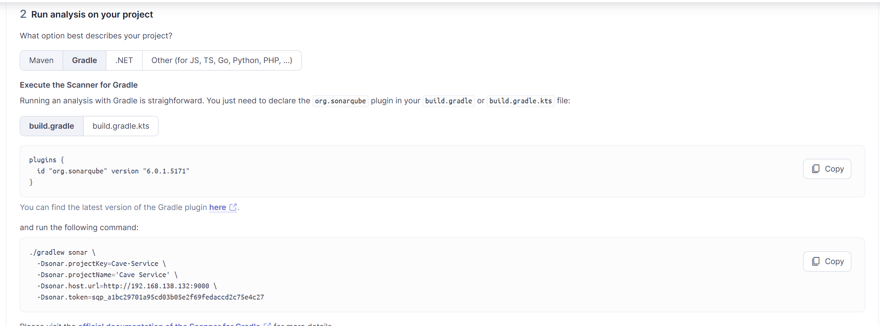

I do need the plugin but then I add the this SonarQube block of configuration.

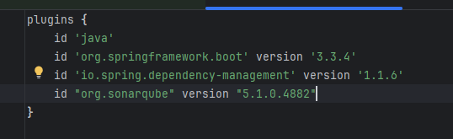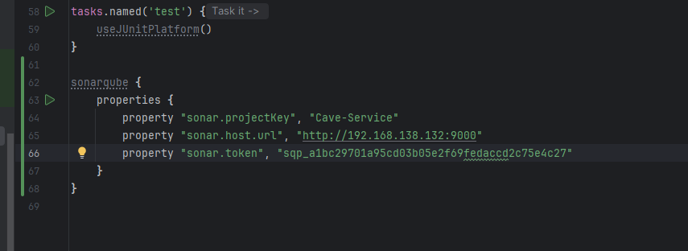

After I do this for all services the SonarQube project list looks something like this:

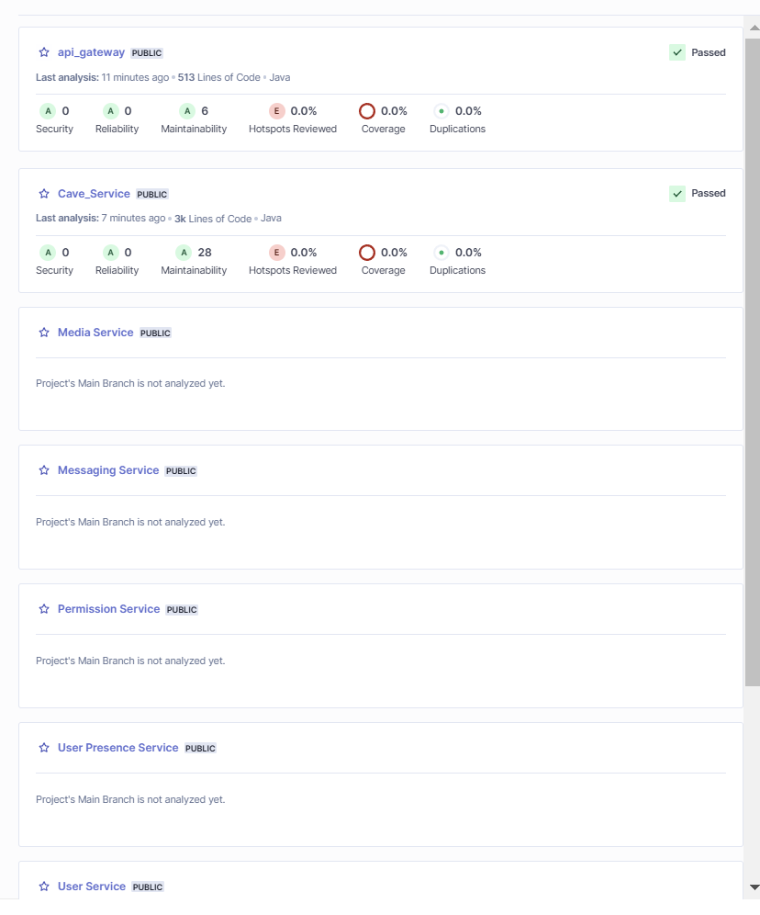

### Snyk VM

Snyk is one of the security tools that I’m using to analyze the code for vulnerable dependencies.

To install Snyk we only need to run the following commands:



“curl https://static.snyk.io/cli/latest/snyk-linux -o snyk”

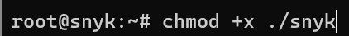

“chmod +x ./snyk”



“mv ./snyk /usr/local/bin/”

After this Snyk will be installed

As a final setup for Snyk we need to get an API Token to use the Snyk application. I have this token stored in Jenkins credentials vault and I inject it into the cli when the job runs.

To get the API token we need to go to [Snyk Portal](https://app.snyk.io/) and create a free account. After once we are logged in we can go to “account settings”.

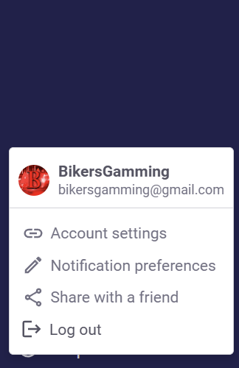

Once here we can create the token.

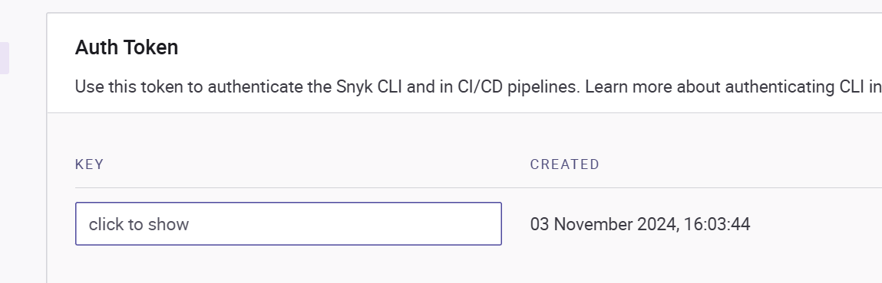

With this the Snyk setup is complete.

## Testing

In this section I will be giving a more detailed breakdown of the different types of tests happening in the system. I already explained the CI part that sets up the environment but now the tests themselves.

I make use of the following tests:

* Unit tests
* Integration tests
* User acceptance tests
* Performance tests

I would have liked to also do end-to-end tests, but I don’t think they add that much value in this case just because the most important concept is having the correct test infrastructure that allows me to test the system in any way I want, and I consider that this was perfectly achieved.

These tests spread out throughout my two testing environments. Unit tests and integration tests run on my proprietary testing Jenkins node. User acceptance tests and performance tests run on the staging environment.

### Environments

#### Test environment

This environment is part of my Jenkins infrastructure having its own server. In this environment all microservices and external services are containerized and deployed in docker. This allows me to create custom environments for each microservice to perform unit tests and mainly integration tests.

The unit tests don’t gain much from this environment, but the integration tests do because I don’t have to mock anything and just allow the normal interactions to happen.

The whole process on how this setup happens was already explained on the jobs portion of this document so I won’t be going through it again.



*Jenkins testing node*

#### Staging environment

The staging environment is much more complex than the previous because in this environment I need to create an entire cloud environment for the system mimicking the production one. The steps for the creation of this environment were already explained in cloud infrastructure job section, but the key components for this are that I make use of terraform to create all the resources with custom values for staging. This environment also benefits of different domain names to ensure separation with the production one.

The staging environment is composed of eleven cloud resources:

* Cloud Redis
* Cloud router
* Cloud NAT
* Kubernetes cluster
* Primary MySQL
* Read-only MySQL replica
* Scylla router
* Scylla NAT
* Scylla node 1
* Scylla node 2
* Performance test VM

More details about these resources and the whole environment can be found on the cloud infrastructure document and the terraform document. In these documents I do a full break down of every single component their configuration and their use.

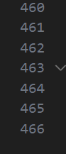

*Terraform file size*

Also, since all microservices have different configurations and identifiers for the staging and production environments, they can both run at the same time with no interfering observability.

The main difference between the staging environment and the production one is the performance test VM. This resource doesn’t exist on the production environment because its objective is to be the platform where I run the performance tests from. I consider this to be a great idea the problem is that I don’t have enough resource quota to make it powerful enough to go to big numbers so at the end I had to use my laptop, but I consider the concept to be of great use.

### Tests

#### Unit test

For unit tests I use the java spring test with Mockito. Mockito is a great framework to mock parts of an application, this allows me to isolate each use case to test it properly against all scenarios.

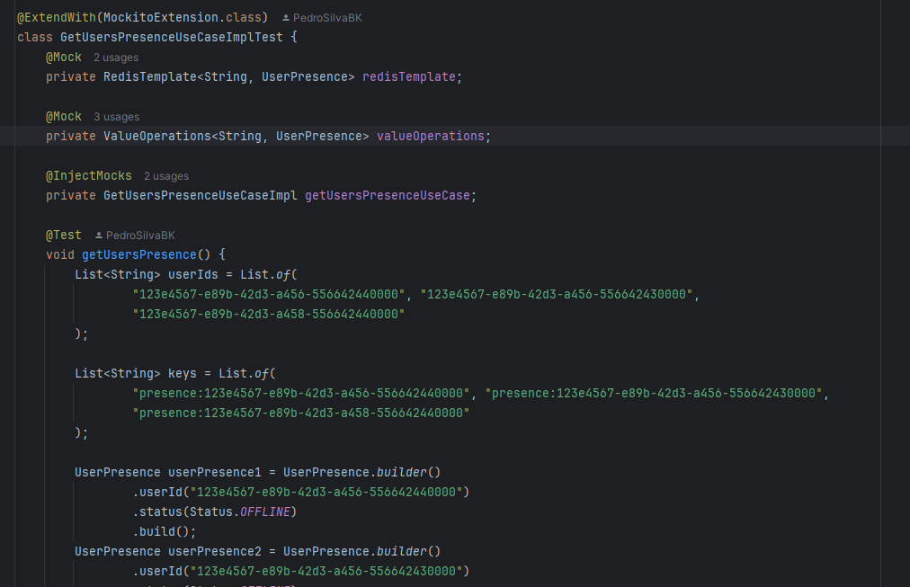

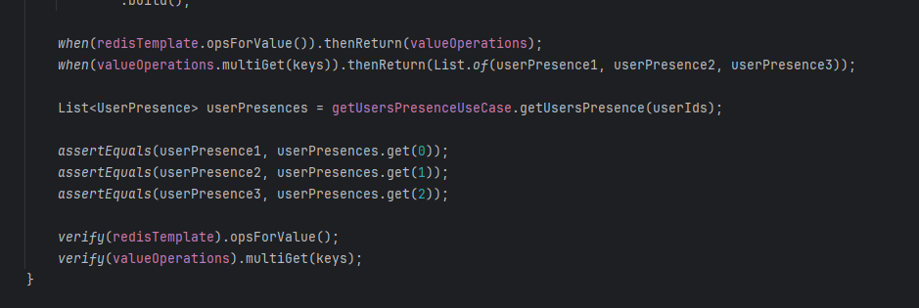

*Example of unit test in one of my services*

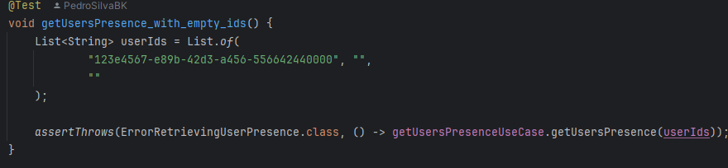

*Example of unit test for exceptions*

#### Integration tests

For integration tests I don’t mock anything, so I allow any interactions to happen. For these I test external service interaction like databases but also API level exposure.

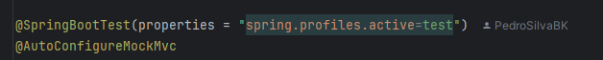

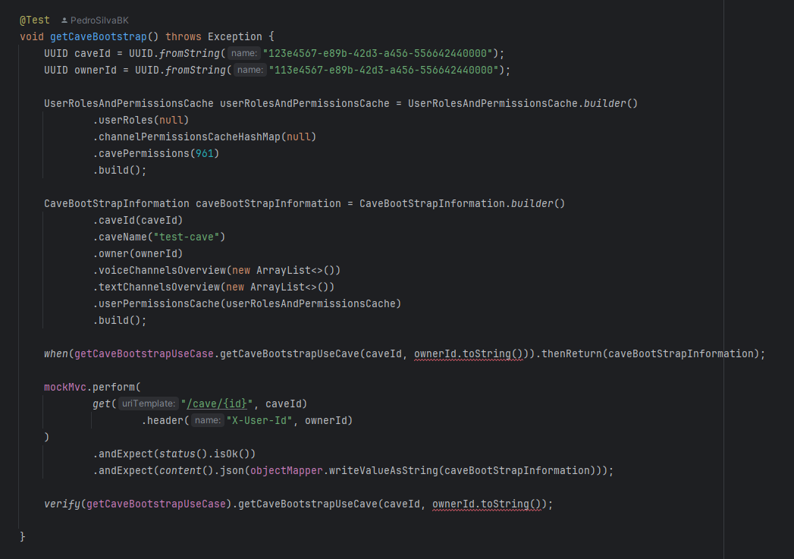

*Example of API level integration tests*

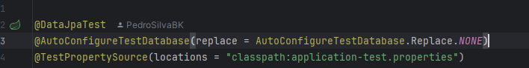

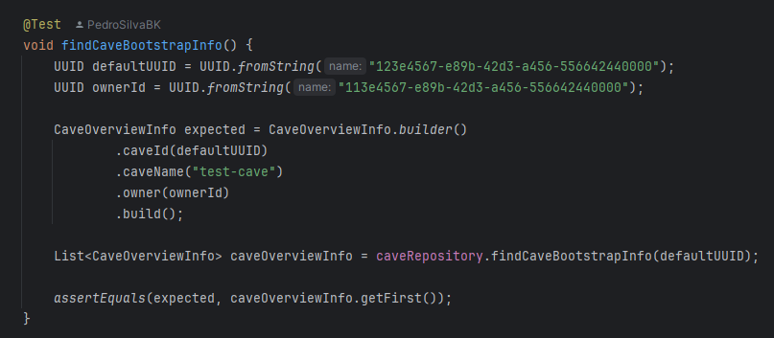

*Example of database integration tests*

The above is quite interesting because by using the @DataJpaTest annotation it makes every test a transaction that gets rolled back when the test succeeds or fails.

#### User acceptance tests

I performed user acceptance tests with a couple of my friends, the idea is that I leave them with a few test cases and make them try to break the application. I did this a few times, but I forgot to capture it because most of the times it was very “freestyle” however I have the last ones I did.

The tests are the following:

**1. Messaging System**

**Testing Goals:**

* Validate that users can send and receive messages in real-time.
* Ensure messages are delivered in the correct order and format.

**Test Setup:**

* Create two or more test user accounts.
* Log in as one user in one device and as another in a separate device.

**Test Cases:**

1. **Basic Messaging:**
   * User A sends a message.
   * Verify User B receives it instantly.
2. **Message Order:**
   * Send multiple messages in quick succession.
   * Confirm they are received in the correct order.
3. **Image sending:**
   * Test if images are correctly sent.
4. **Edge Cases:**
   * Test with very large messages.
   * Handle cases like empty messages gracefully.

**Test Cases results:**

1. **Basic messaging**

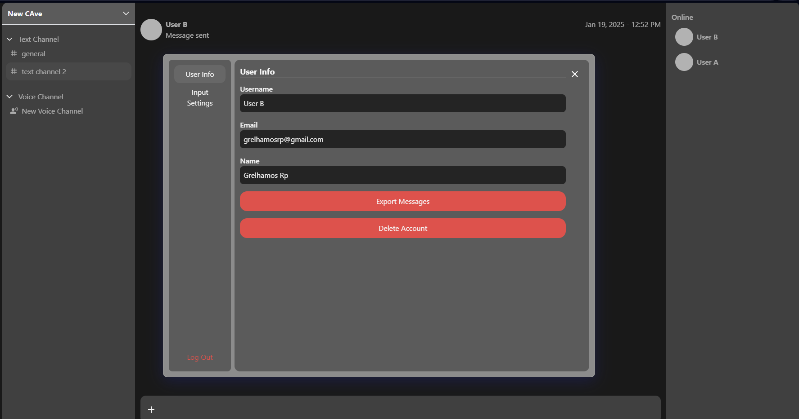

User B sent a message

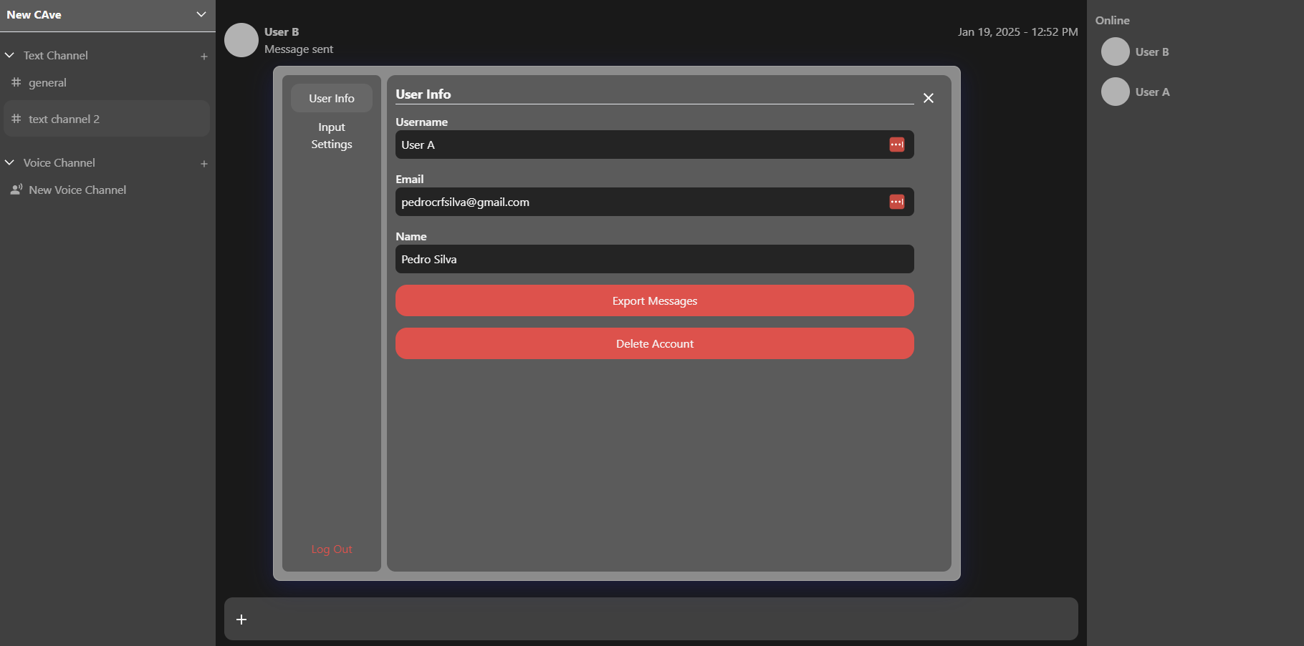

User A instantly received the message

1. **Message order**

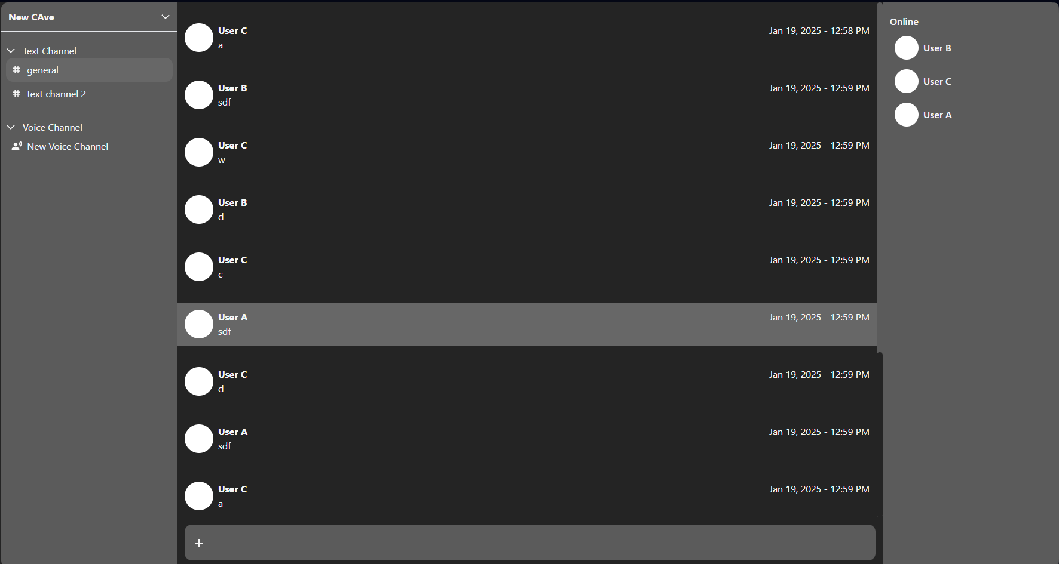

With three users all in different devices we can see a real-time instant communication between all of them.

1. **Image sending**

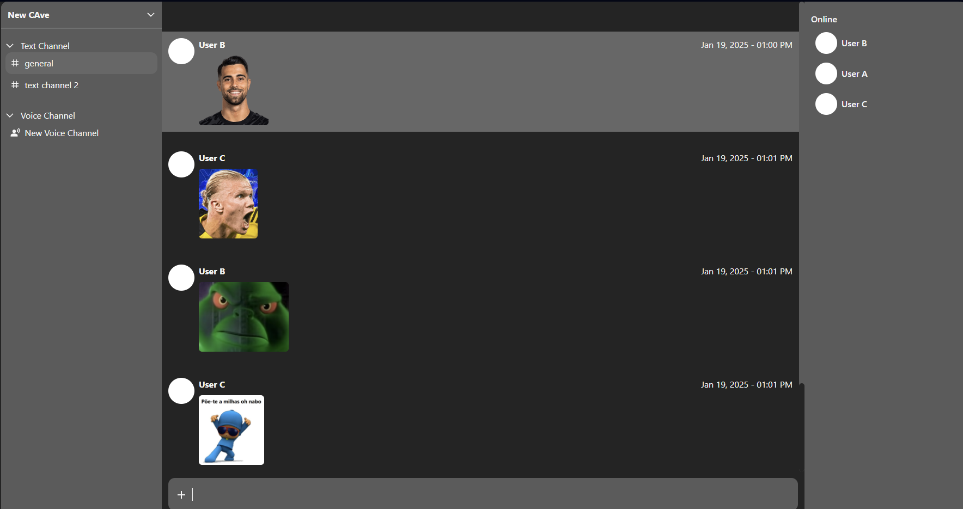

Here we can see each client can send and receive images as messages.

1. **Edge cases**

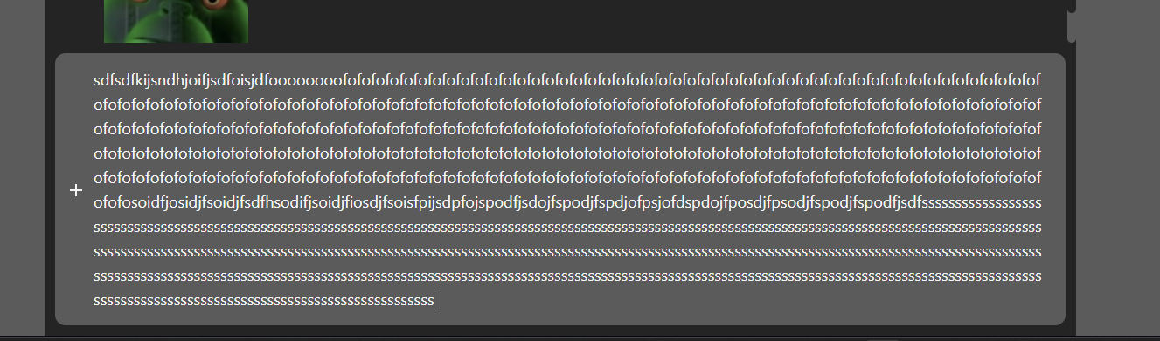

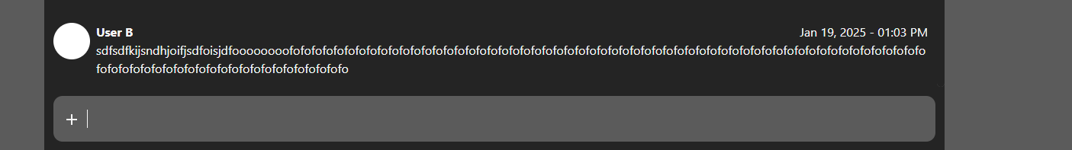

There aren’t clear error messages about the limitations and that’s something that should be added but it isn’t possible to send messages bigger than 255 characters.

**2. Permissions**

**Testing Goals:**

* Validate user permissions for sending messages, viewing channels, and other actions.
* Confirm that permissions update in real-time.

**Test Setup:**

* Configure roles and permissions in your system (e.g., Admin, Member, Guest).
* Assign roles to test accounts.

**Test Cases:**

1. **Send Messages:**
   * User with "send message" permission sends a message successfully.
   * User without permission has disabled input.
2. **View Channels:**
   * User with access can see the channel in the list.
   * User without access cannot see the channel in the UI.
3. **Permission Updates:**
   * Update permissions (e.g., grant "send message" permission to a user).
   * Verify the update reflects in real-time without a page refresh.

**Test Cases results:**

1. **Send messages**

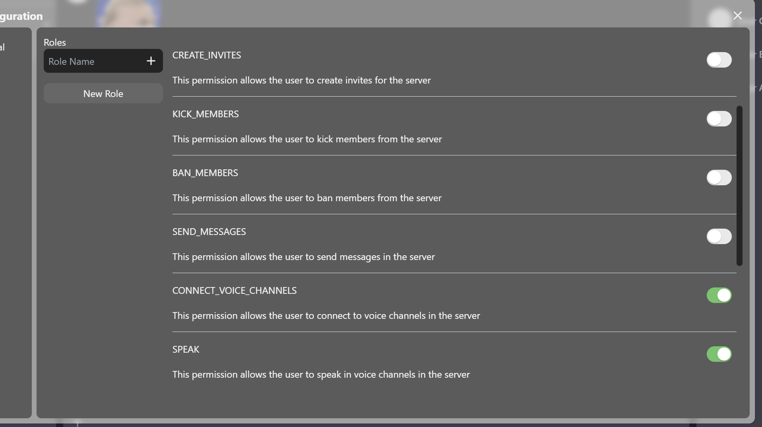

User A, the admin, creates a role and sets the role permission for not being able the send messages

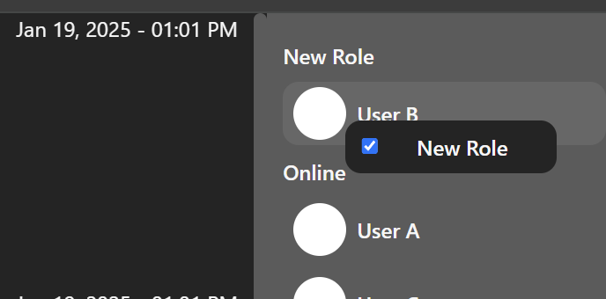

User A gives that role to User B

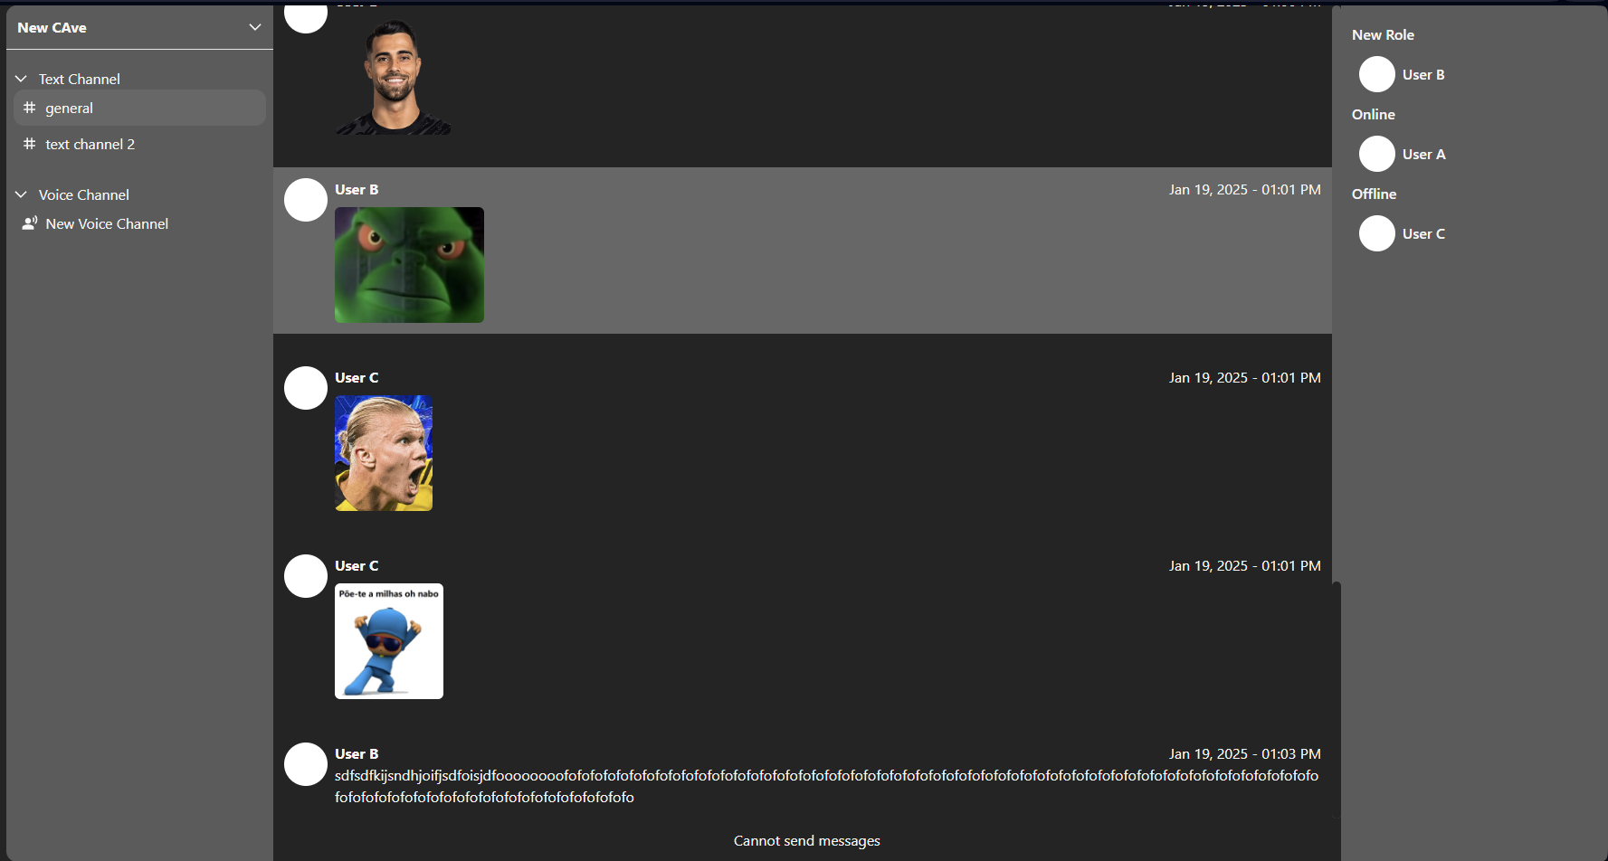

User B can no longer send messages.

1. **View channels**

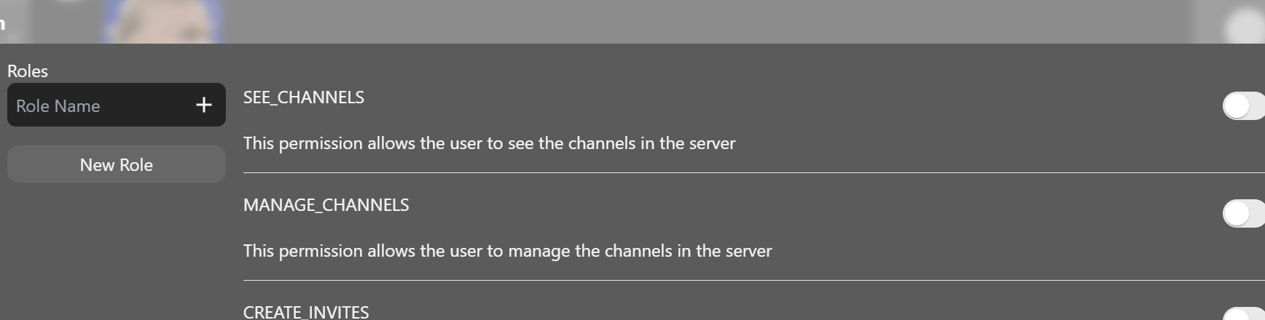

User A removes SEE_CHANNEL permission from the Role.

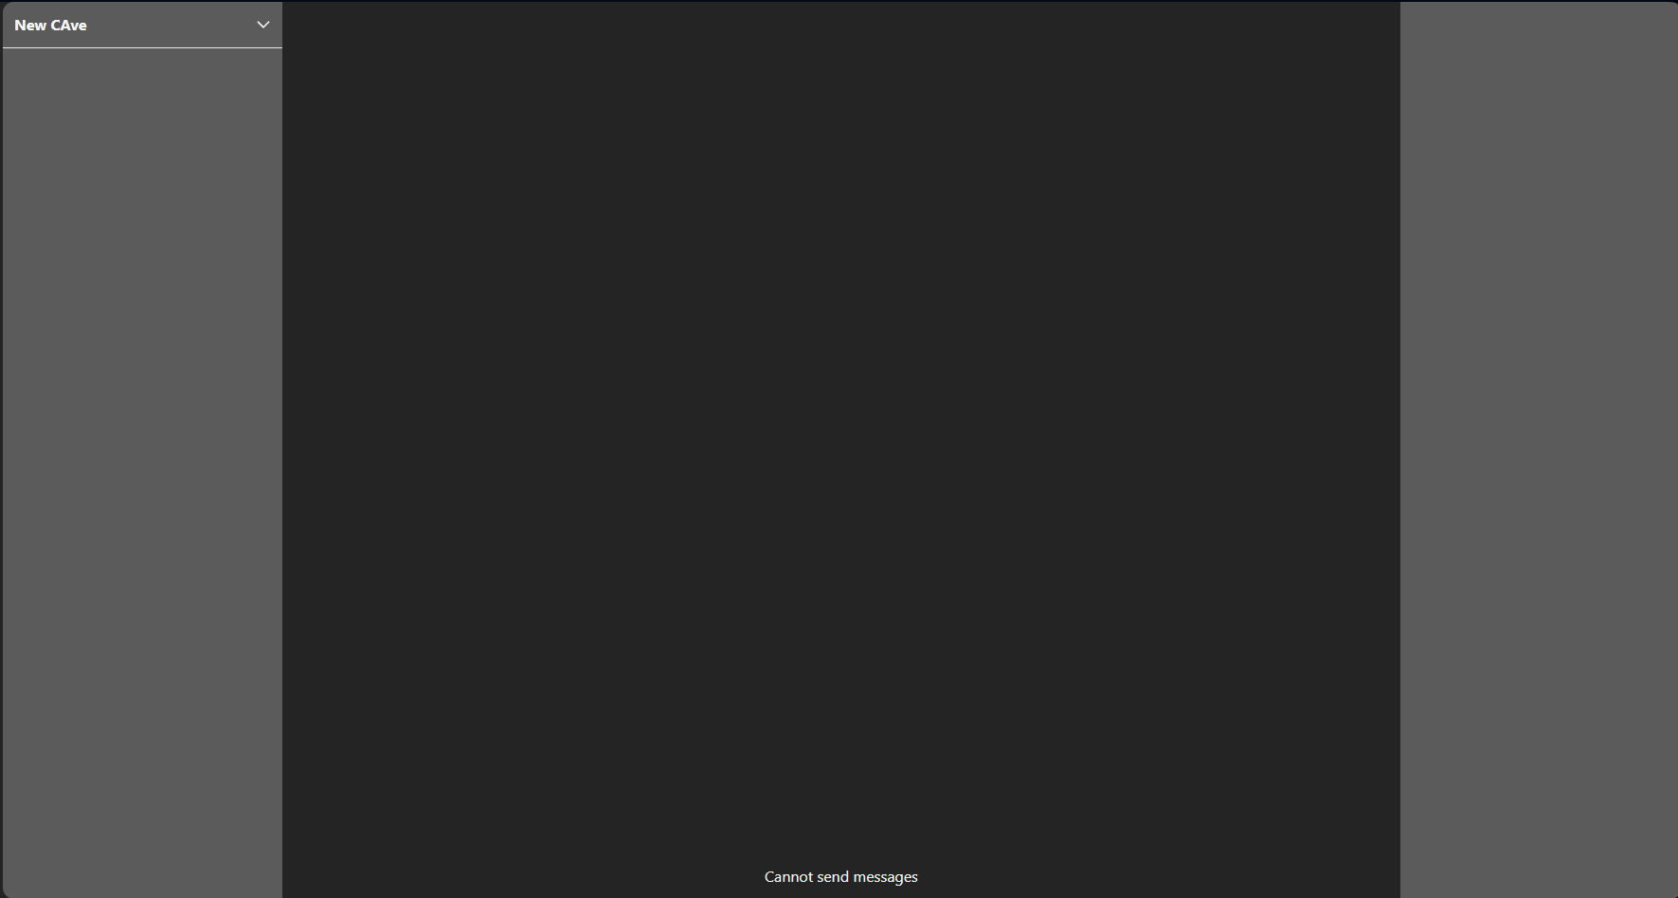

User B that has the role can no longer see any channels.

1. **Permission Updates**

I cannot show this without a recording, but all showcases related to permissions happen in real time without any need for refreshing the page.

**3. Real-Time Updates**

**Testing Goals:**

* Ensure changes (e.g., role updates, channel changes) propagate instantly to all connected clients.

**Test Setup:**

* Open multiple clients (devices) logged into different accounts in the same cave.

**Test Cases:**

1. **Role Updates:**
   * Change a user’s role (e.g., from Member to Admin).
   * Verify the update reflects instantly on their client.
2. **Channel Updates:**
   * Add or remove a user from a channel.
   * Verify the channel list updates in real-time.

**Test Cases results:**

1. **Role Updates**

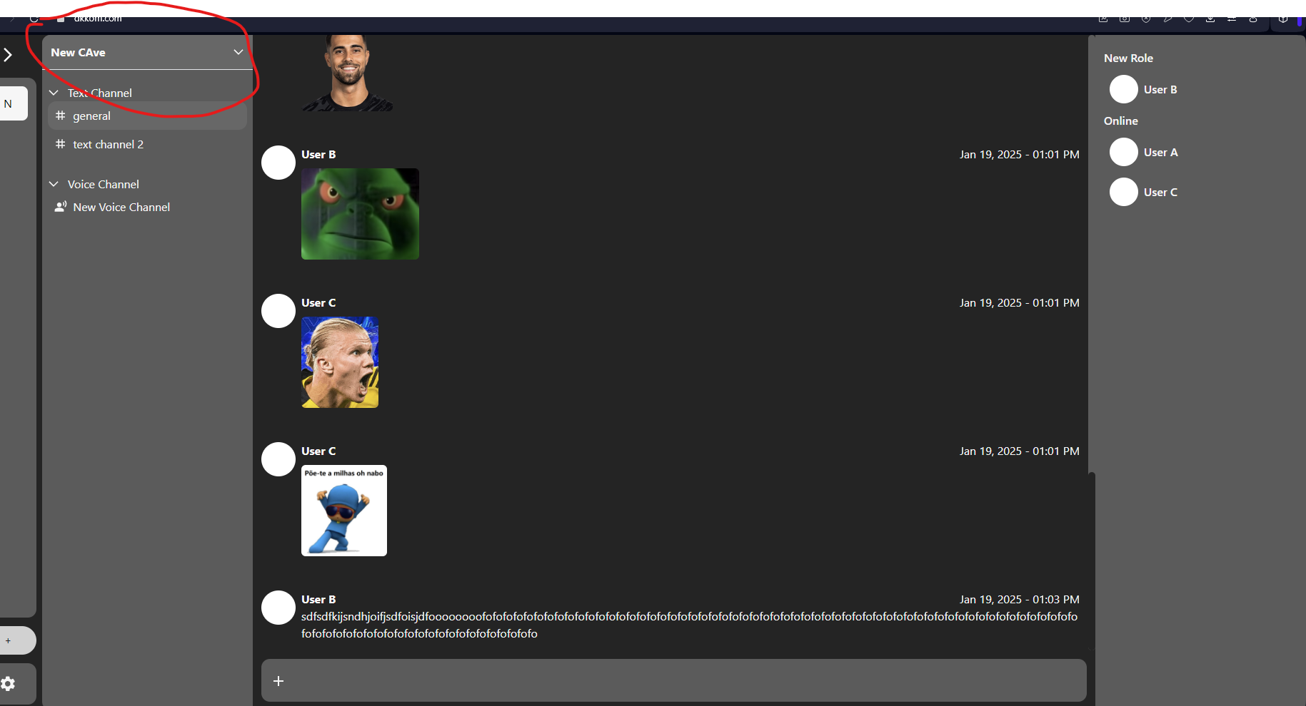

The upper panel cannot be open without being an admin or having permissions per option of the panel.

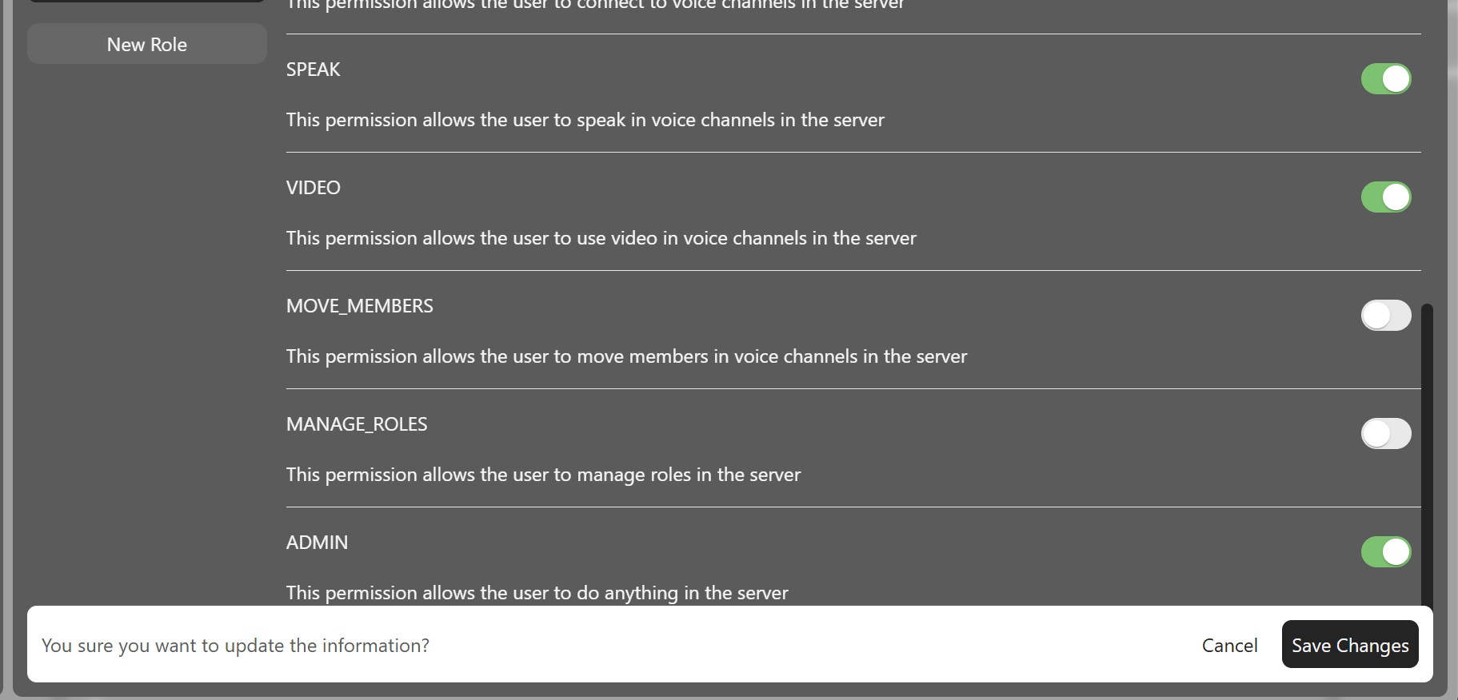

Admin updates user role to be an admin

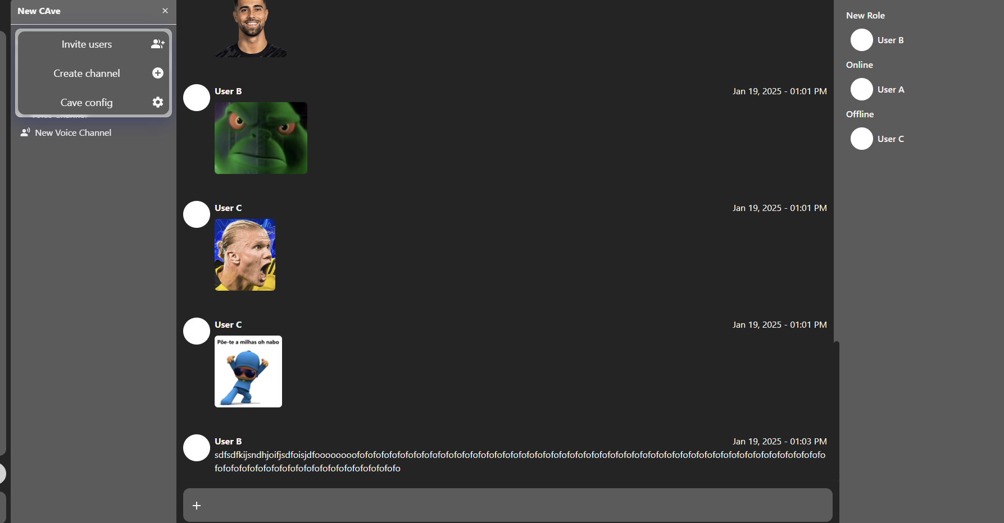

Now user B can see the panel.

1. **Channel Updates**

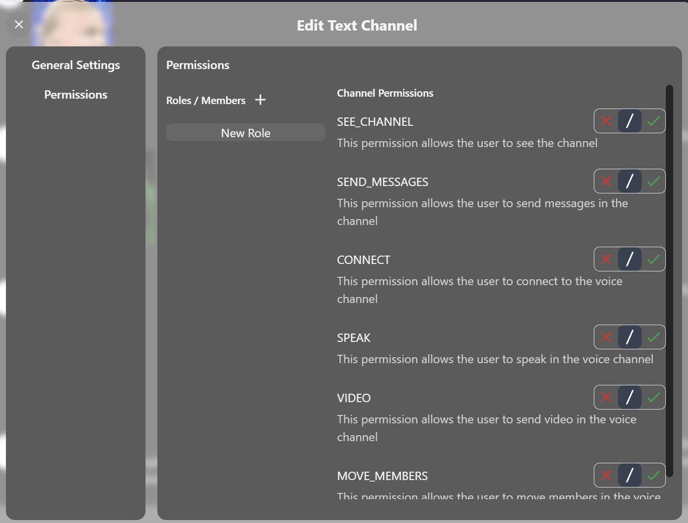

This menu is for overwriting role permission on a channel.

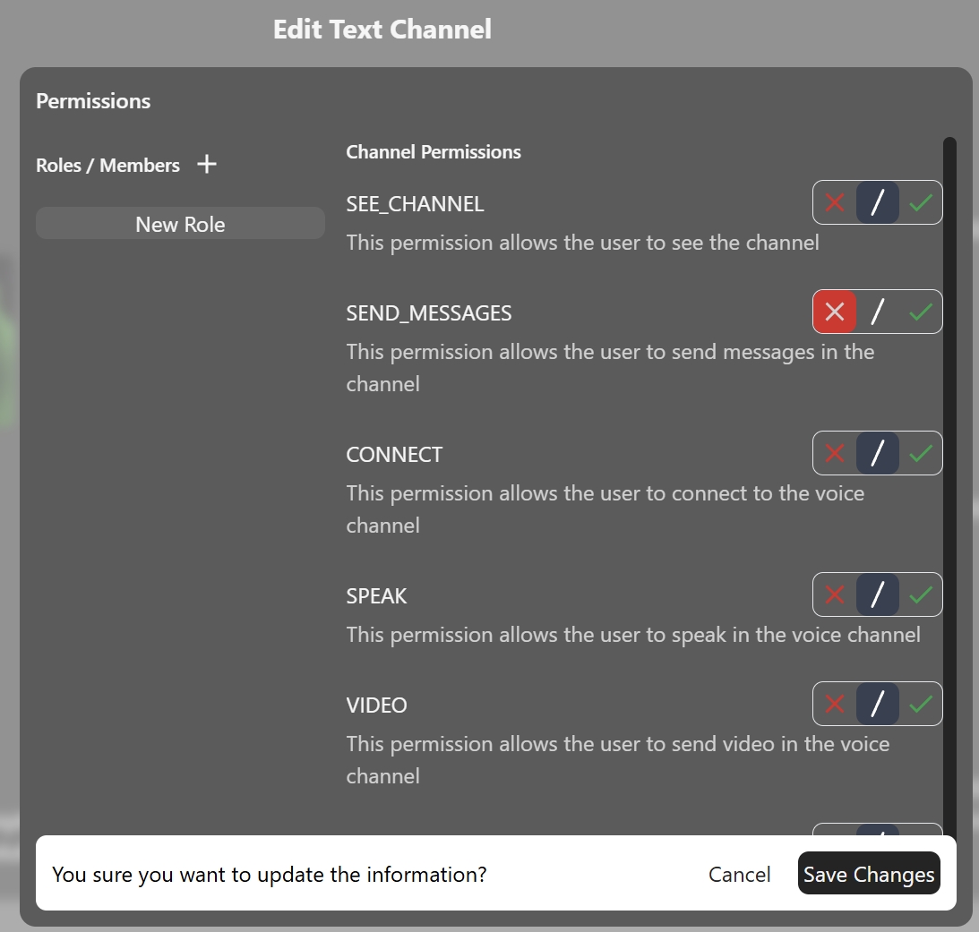

Here User A creates this overwrite on this channel to no allow users with this role to send messages.

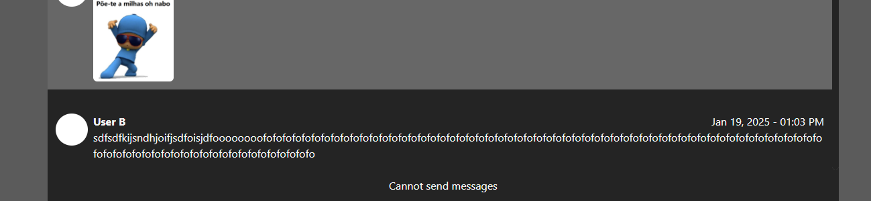

User B can no longer send messages on this channel.

**4. Voice Communication**

**Testing Goals:**

* Verify that users can connect to voice channels.
* Confirm audio quality, latency, and synchronization.

**Test Setup:**

* Use two or more devices to simulate multiple participants in a voice channel.

**Test Cases:**

1. **Joining a Voice Channel:**
   * User joins a channel and hears existing participants.
   * Late joiners hear ongoing audio correctly.
2. **Real-Time Communication:**
   * Verify voice is transmitted in real-time with minimal lag.
   * Check for echo, feedback, or other distortions.
3. **Edge Cases:**
   * Test with multiple participants speaking simultaneously.
   * Handle user disconnects gracefully.

**Test Cases results:**

1. **Joining a voice channel**

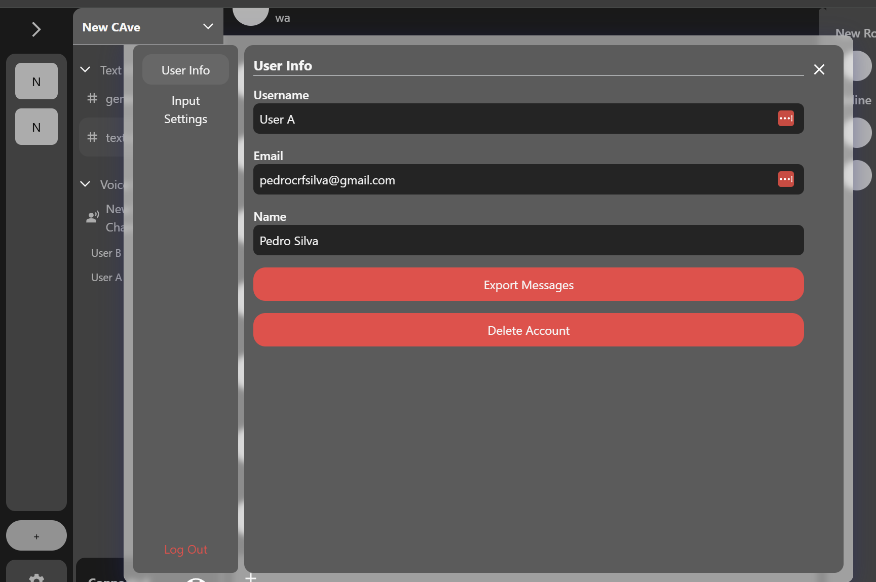

As we can see User A is connected to the voice channel

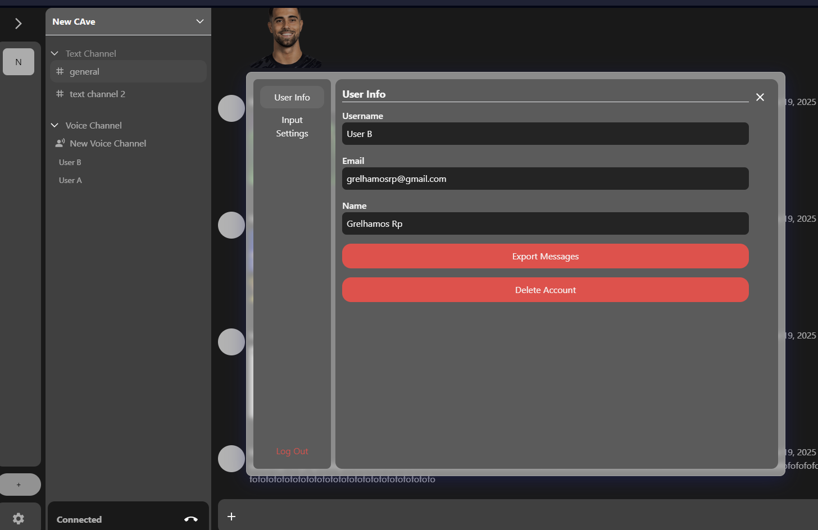

User B is connected to the voice channel

1. **Real-Time Communication**

Unfortunately, there isn’t a way to demonstrate this without recording it. The only thing I can show via screenshots is the receiving of the audio remote track on each user.

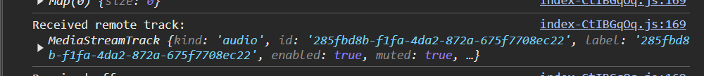

User A receiving remote track for the channel



User B receiving remote track for the channel

1. **Edge cases**

The communication part needs to be recorded; however, the disconnecting part can be shown via screenshots.

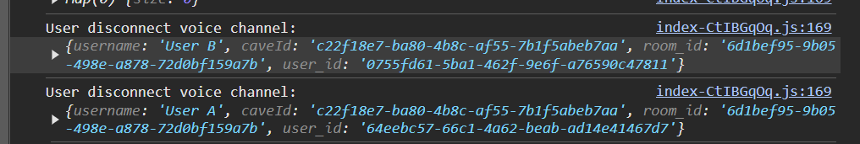

This event is transmitted to anyone in the channel if someone disconnects. This is the result of a user being removed from the audio track streamed by the SFU.

#### Performance tests

The performances tests are described on the Performance tests word document. There I go into a very detailed explanation of my findings and how I conducted the tests.

#### Test Conclusion

The selected tests and their execution environment allow me to understand more about my application logic and prevent errors from going into production. The only tests that I also would have liked to perform would be end-to-end tests since I think they are also very helpful, however I didn’t have the time.

## Monitoring

In this section I will be going through the monitoring part of my system which is a crucial part of the Ops part of DevOps.

### Logs

All my applications produce logs that are gathered by google cloud and stored in centralized system and accessible by custom dashboards. With this setup I can see all logs from my system / infrastructure and see if everything is behaving correctly.

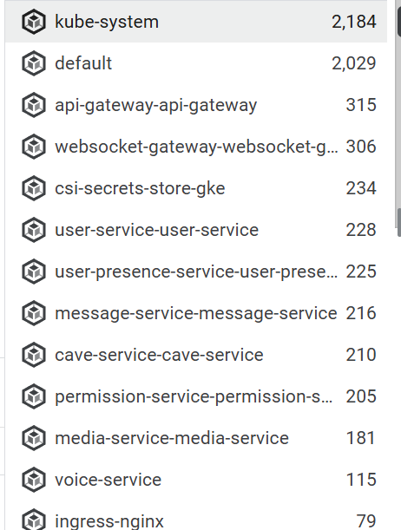

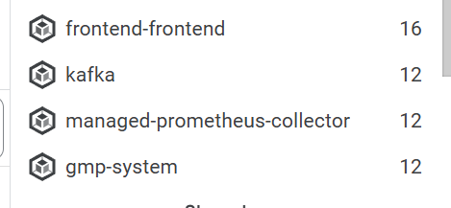

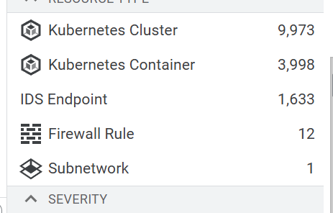

*Example of different types of logs on my system / infrastructure*

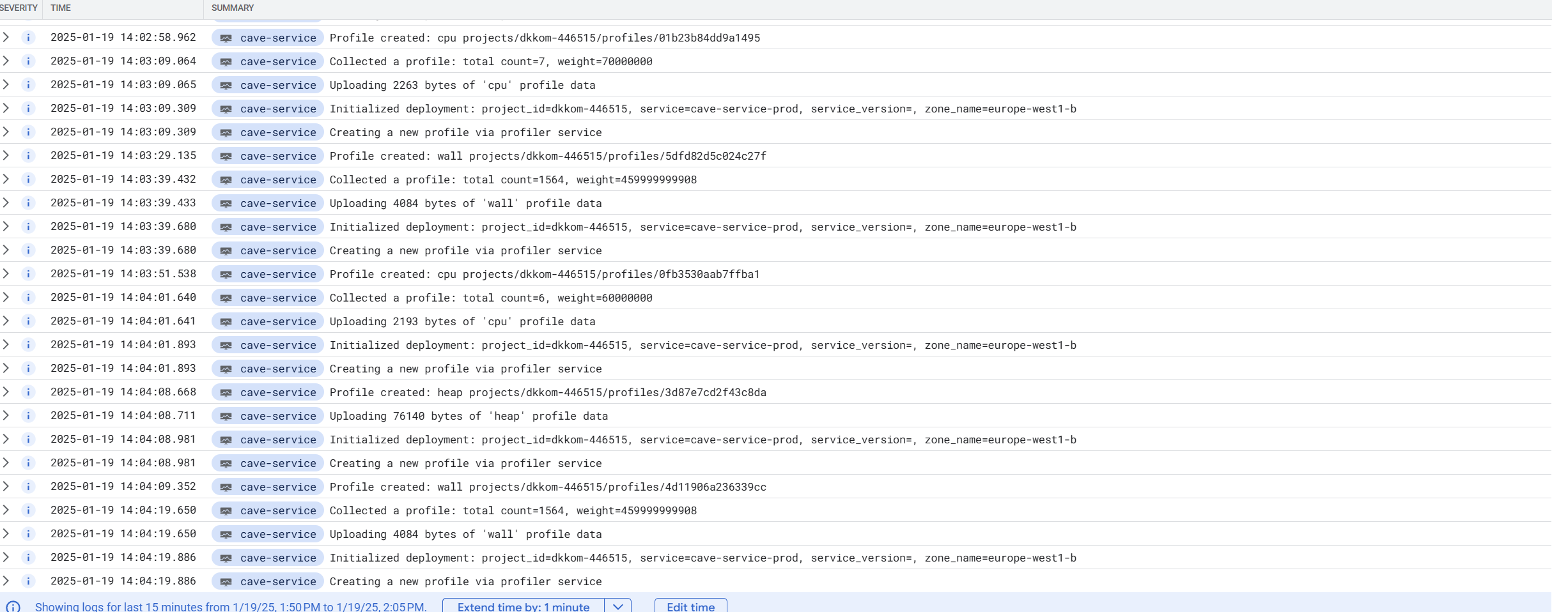

*Example of logging view.*

### Metrics

Every single component of my system has metric being registered constantly. This is default behavior that I have for all my cloud resources, but I also added this to my individual services. All these metrics are than visible in custom dashboards.

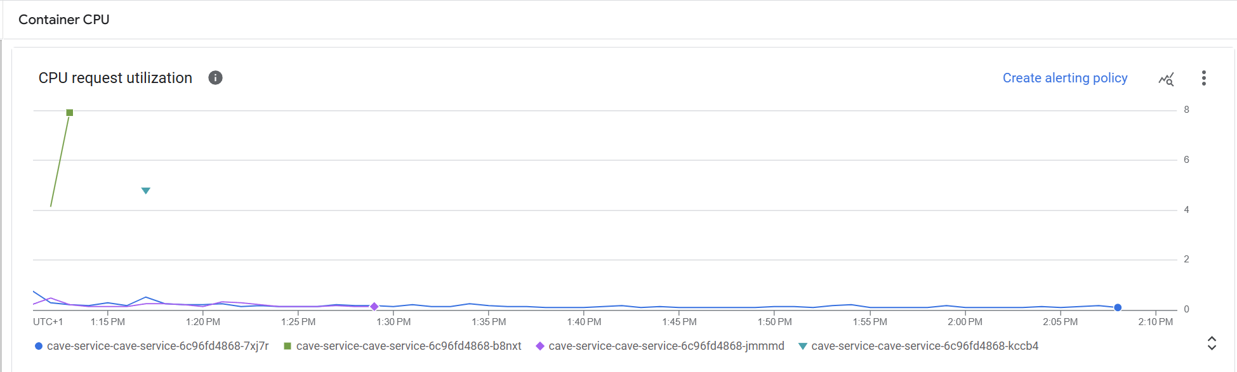

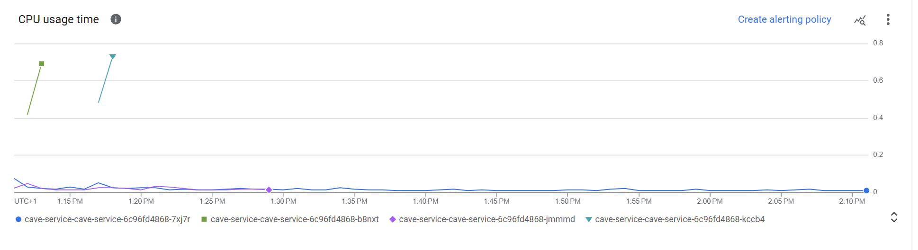

*CPU metric for one of my services*

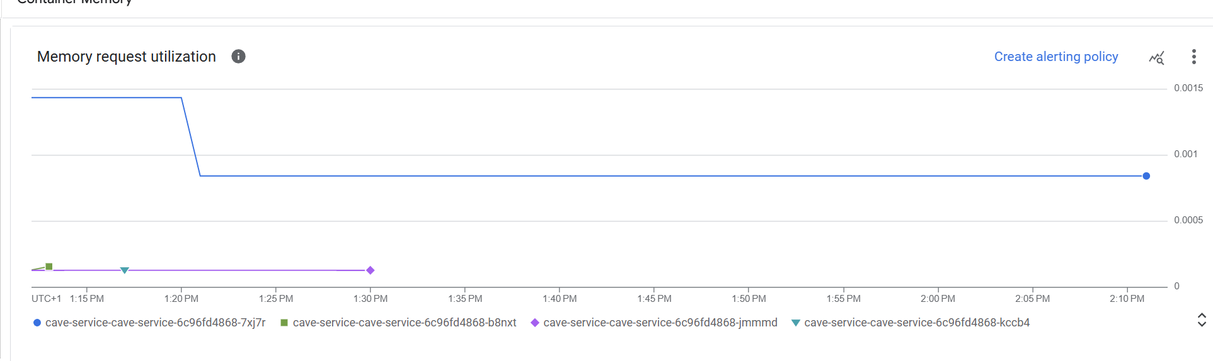

*Memory metrics for one of my services*

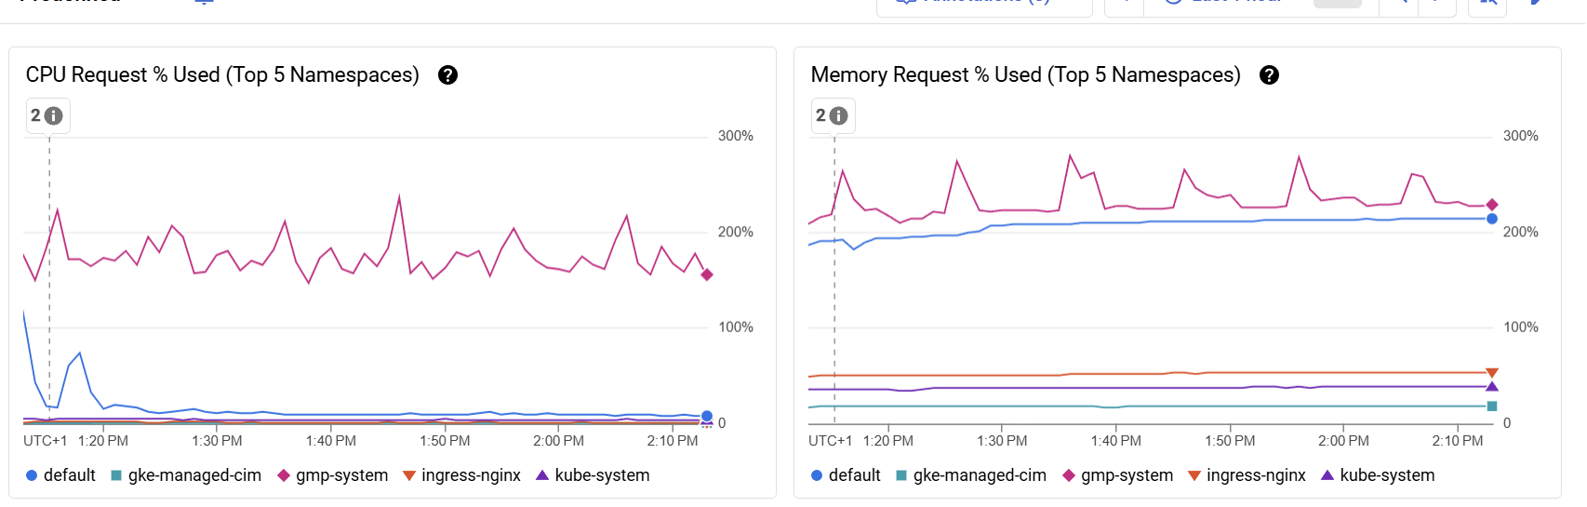

*Kubernetes cluster CPU and memory metrics*

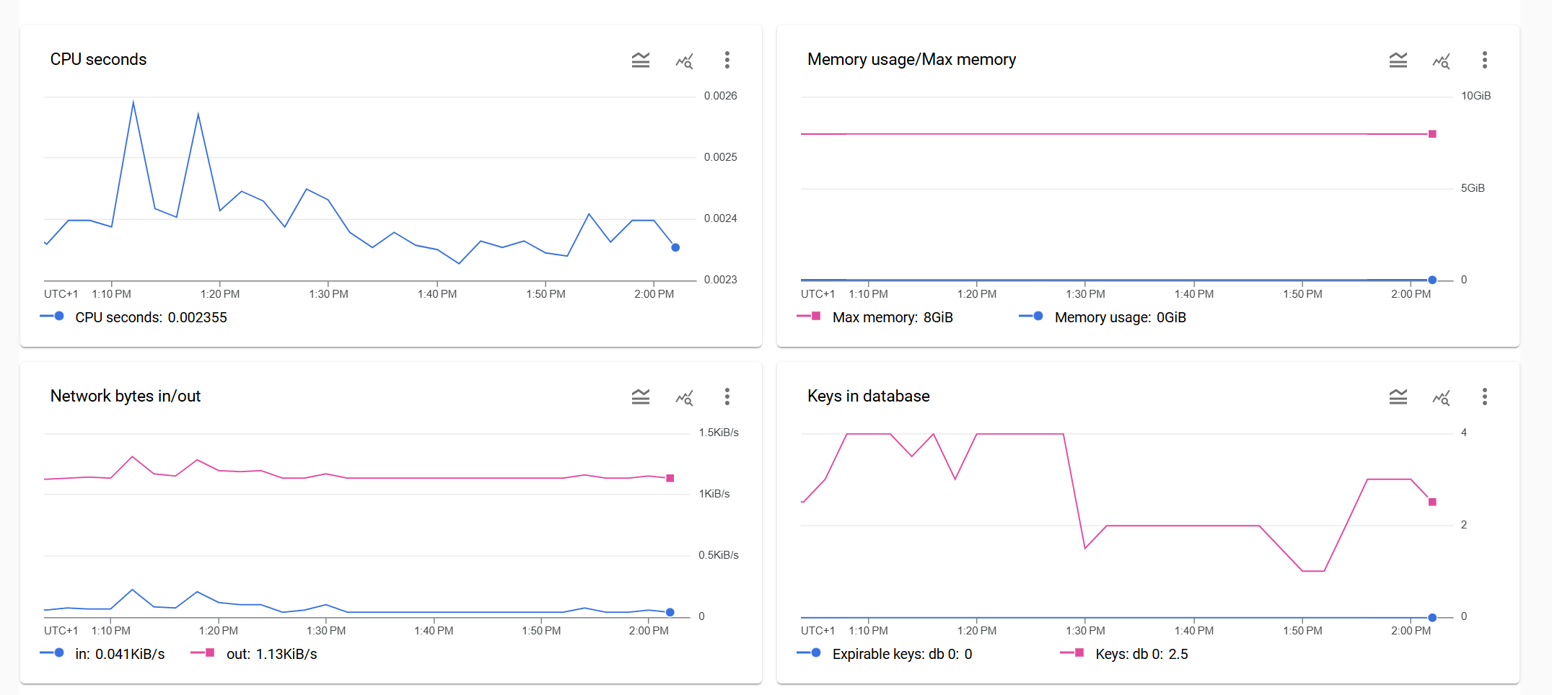

*Redis CPU, Memory, Network and application-level metrics.*

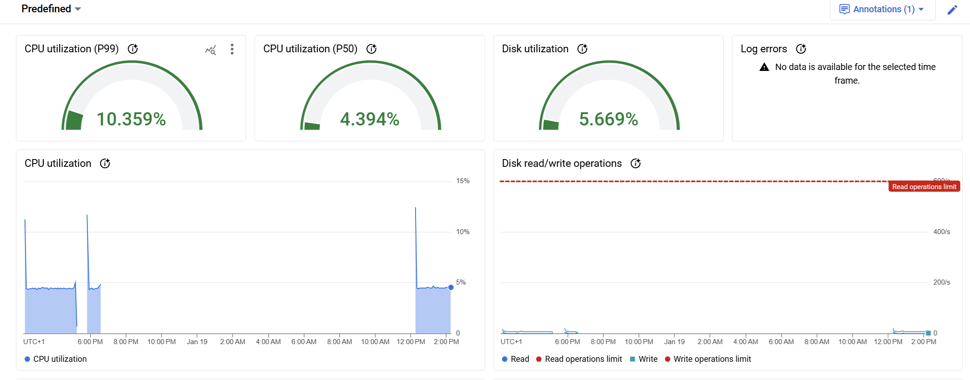

*MYSQL instance CPU and application-level metrics*

All these metrics allow me to analyze everything that is happening on my application and more importantly create custom alerts for them to see if anything is out of the ordinary.

### Traces

Tracing is another aspect of monitoring that I have implemented on all my services. This is somethings that has its own custom implementation.

For this setup I chose to attach an open telemetry java agent to each one of my applications. This agent collects metric periodically and sends them to a collector, this collector than uploads them to Google’s servers.



*Download the open telemetry agent when building the image.*

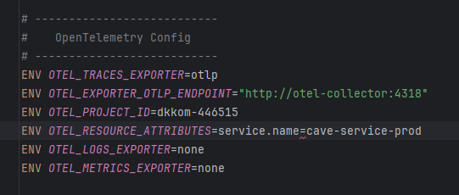

*Configuring how the agent will communicate with the collector.*



*Specifying the location of the agent to mount to the main java application.*

After this setup I can go the trace dashboard and see all the application traces.

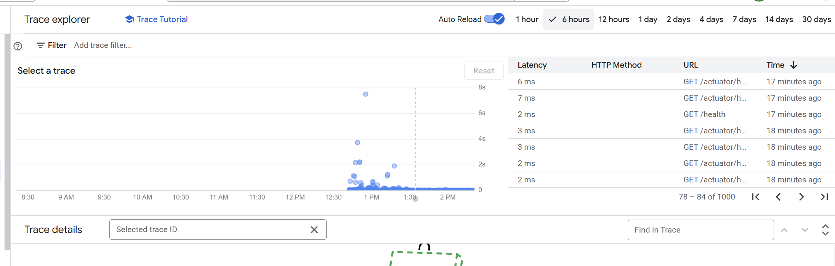

*Trace Dashboard*

*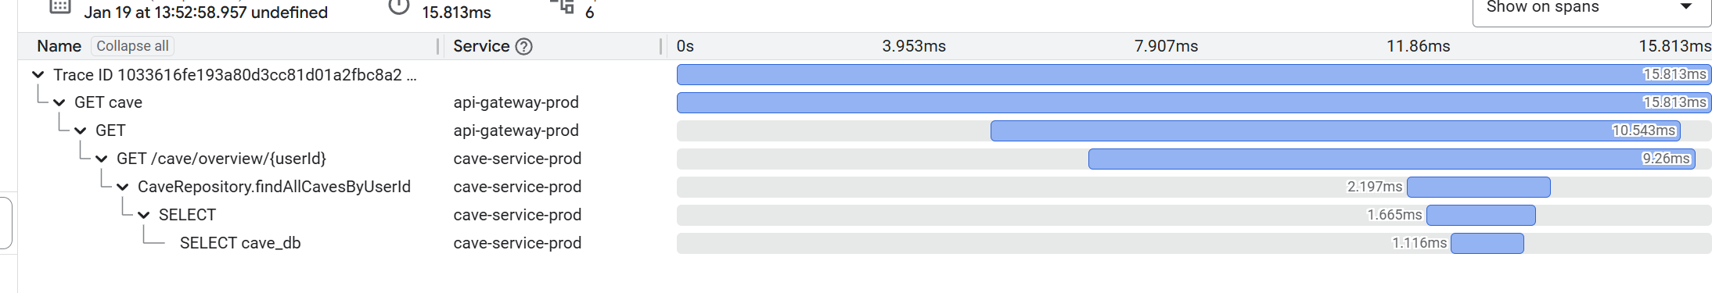Example of a trace*

Tracing tooling is an incredible addition to any project. I never used tracing before, but from now onwards I will always have it since it gives amazing insight into all the different interactions that happened on a single event which is crucial in microservice debugging.

### Profiling

Profiling is another method that I never used and find very interesting. For my case I integrated profiling with google cloud. For that I had to also a profiling agent to my application. This agent is provided by google so the only thing I need to do is download the agent into the environment of the application, attach it to the java process and make sure I have the google credentials setup as an environment variable.



*Downloading and setting up the profiling agent*



*Attaching the agent to the java process.*

With the profiler I have configured 3 profile types: CPU Time, Wall, Heap

Wall: is the real-world elapsed time for a piece of code or operation, as measured by the clock on the wall.

CPU time: measures the amount of time the CPU is actively executing instructions for a specific thread or process.

Heap: The heap refers to the portion of memory used the application for dynamic memory allocation, where objects, variables, and data structures are stored at runtime.

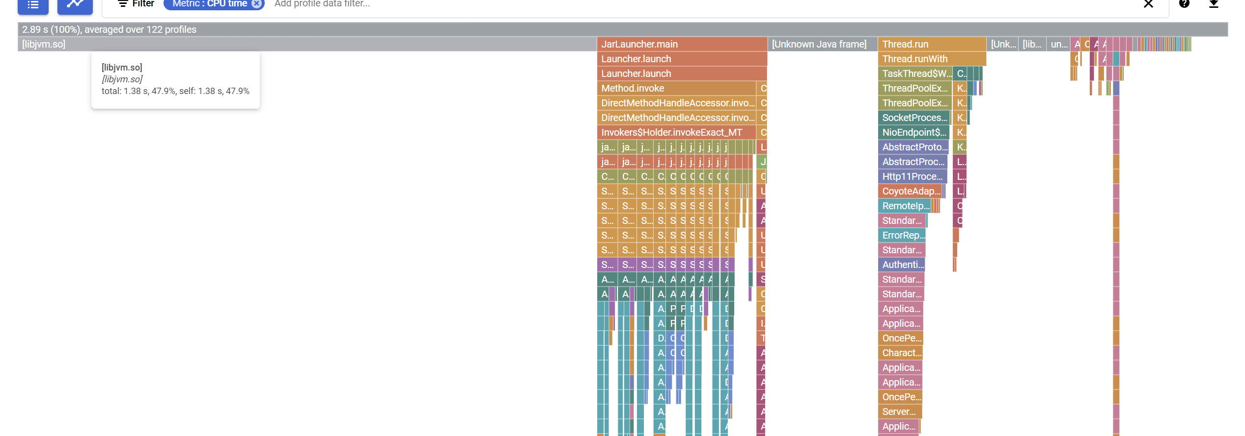

*Example of CPU time for a service*

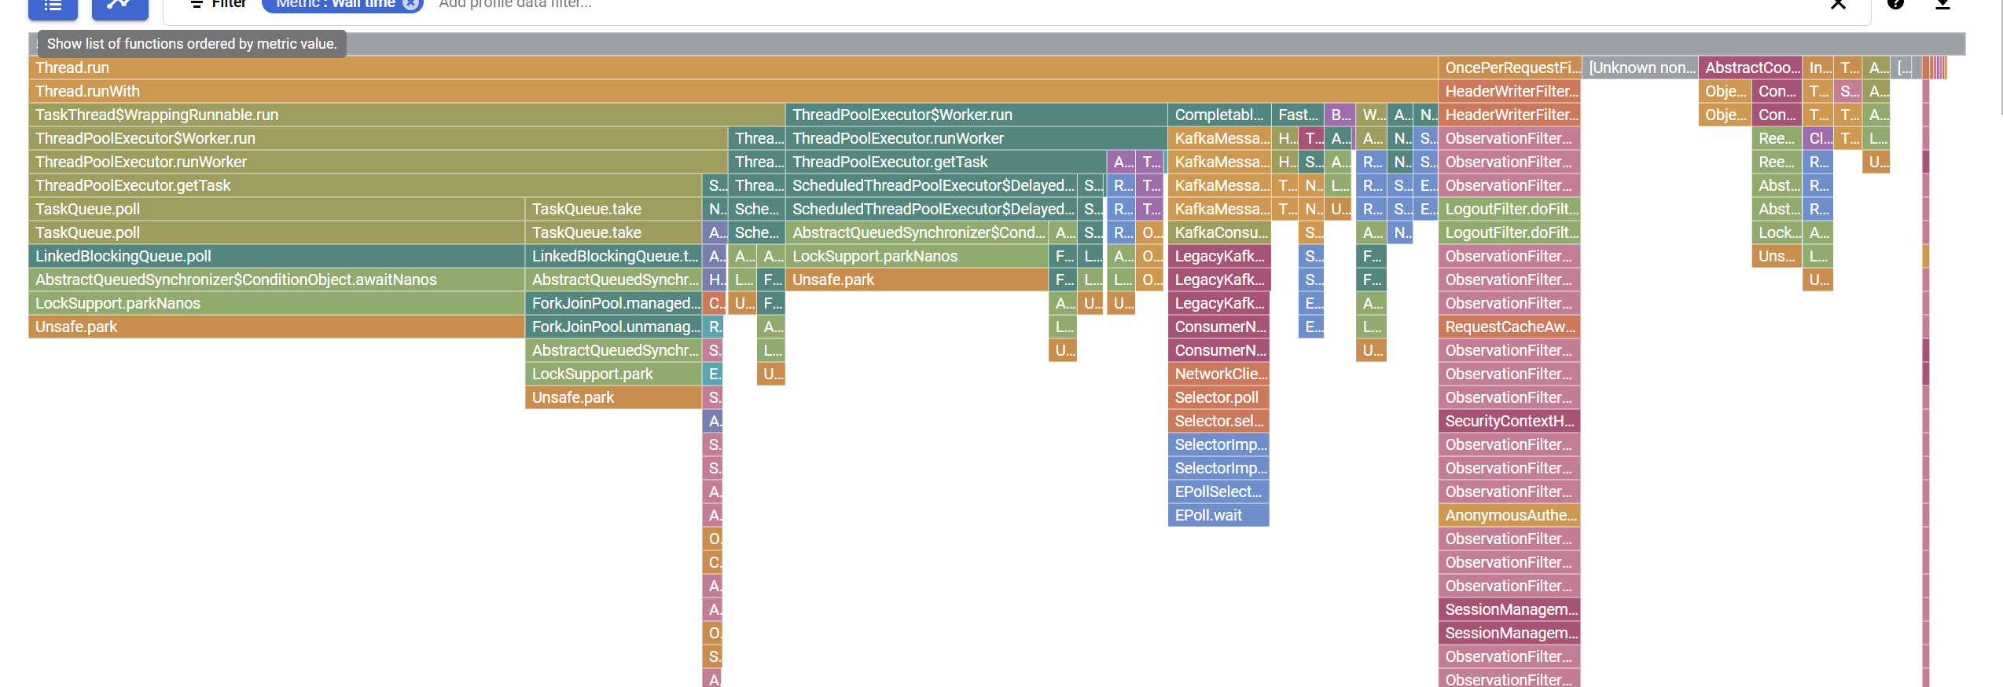

*Example of wall time for a service*

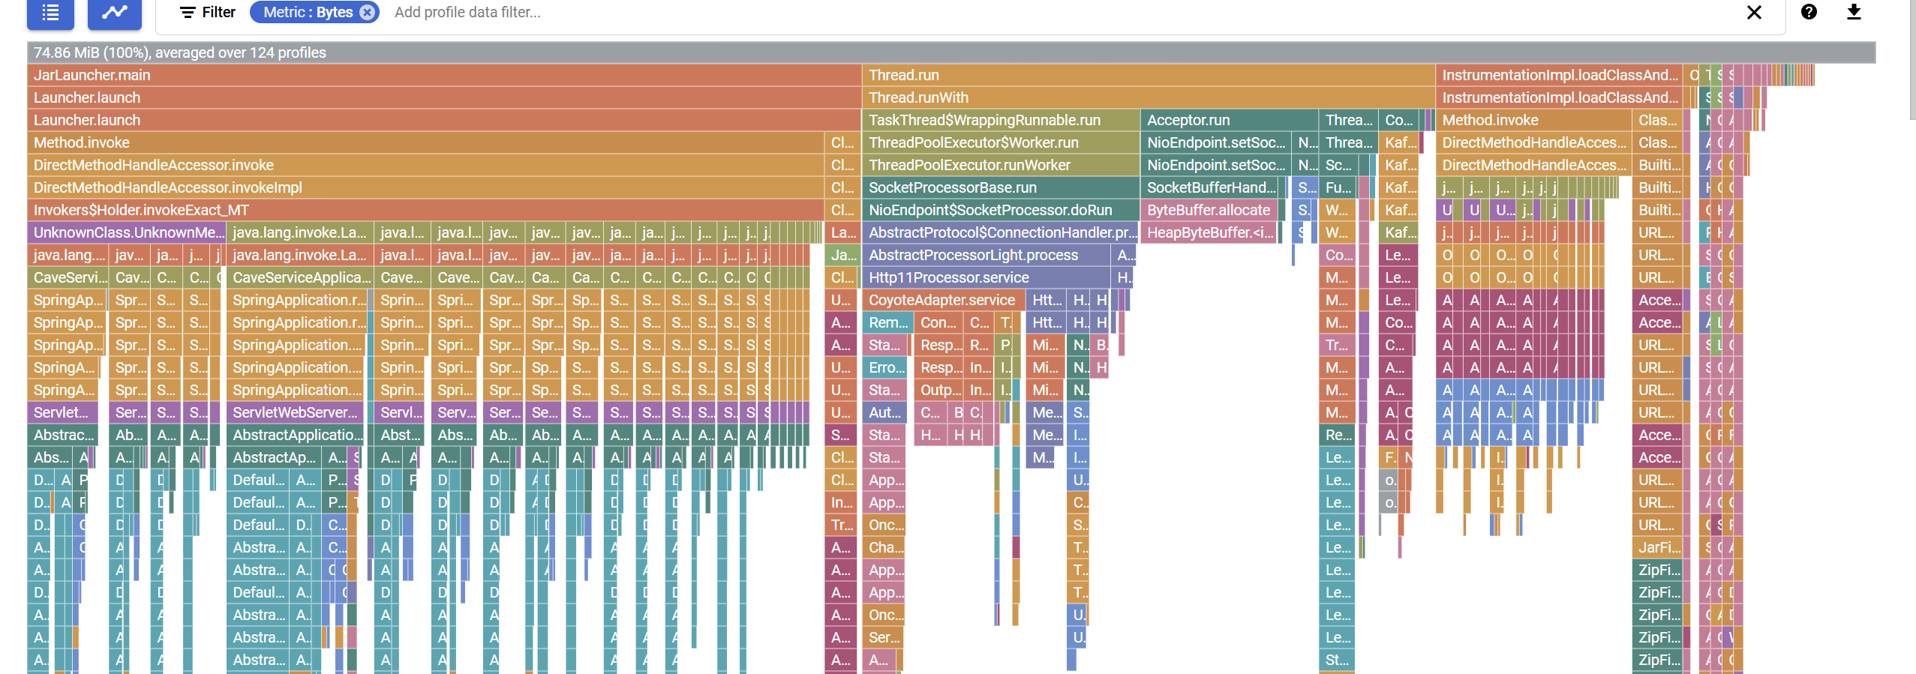

*Example of heap for a service*

These three as profiling types are very helpful to analyze the application behavior and go more in depth on which part of the code is consuming more resources. However, In my particular case most of the resource consumption comes from spring framework itself and not from my own code which is very interesting and clearly shows why for extremely fast systems lower languages with no frameworks are used.

### Security dashboards

I have several security checks and monitoring throughout my application and infrastructure. This is all explained into detail in my Security Document.

## Conclusion

This was one of the most time-consuming topics I did the entire semester. I think I have an extremely complete DevSecOps environment with maintainability and extensibility in mind. My setup allowed me to have a very enjoyable development experience, especially on the cloud side of the process. Throughout this cycle I relied a lot on cloud tooling because they are most of the times perfectly configured out of the box which saves time; however, I would like in future to create my own infrastructure for all these specially on the monitoring / observability side. Aspects like logging tracing and metric collection look extremely interesting specially in a distributed system.

As a last remark there is a LOT of moving pieces here and I hope I managed to capture all of them and if something isn’t very clear, I that at least is deductible.